Trimble Differential GPS Handbook  Draft compiled August 16, 2014 | Draft  Guidelines provided for the Trimble Model R7 and Model R8 units and Trimble Business Center. Please feel free to note suggestions in this draft document where appropriate. Email Ryan Cody rcody@utep.edu

1 Overview 2
1.1 Base Station 3
1.2 Components and Setup 3
1.3 Remote Access 4
1.4 Guidelines for Setting up a Temporary Base Station 5
2 Trimble Rovers 9
2.1 R7 Components and Gear Setup 9
2.2 R8 Components and Gear Setup 13
3 Survey types 13
3.1 Configure the Controller & Conduct a PPK Topo Point or Continuous Topo Survey 13
3.2 Fast Static Survey (FSS) 20
3.3 Static Survey (FS) 22
3.4 Post Processed Kinematic Survey (PPK) 22
3.5 Real Time Kinematic Survey (RTK) 23
4 Post Processing Using Trimble Business Center 26
4.1 Folder structure 26
4.2 Download Data from Survey Controller 26
4.3 TBC Initial Configuration 27
4.4 Create a “Project Template” for Barrow 27
4.5 How to add an online base station (grab from section in Amorita’s doc) 33
4.6 Import Base Station data from the Internet 37
4.7 Process Baseline 45
4.8 Process Continuous Topo 46
4.9 Exporting Processed Data 46
5 View Exported DGPS data in Quantum GIS 48
5.1 Format the CSV Data and Save as an Excel Spreadsheet 48
6 Appendix 48
6.1 Check list for heading to the field with R7 48
6.2 Check list for heading to the field with R8 48
6.3 Equipment Inventory at Barrow 48

Overview

UNAVCO, CH2M Hill Polar Services, and UMIAQ operate a high-precision GPS (RTK and post-process) surveying system in Barrow and Atqasuk in support of National Science Foundation sponsored research. The system provides centimeter level differential corrections to properly equipped users in the vicinity of the Barrow Environmental Observatory (BEO), allowing for stake-out surveys and real-time survey data collection. The system is not compatible with hand-held GPS navigation receivers.

The University of Texas at El Paso, Systems Ecology Lab provides on site support for
Differential GPS mapping at Barrow, Atqasuk and Ivotuk from June 1 – August 15 each
Summer. This support is provided to facilitate the documentation of current and historic research sites and is funded by the National Science Foundation as part of the Barrow Area Information Database (BAID) project. For info visit http://barrowmapped.org/.

This DGPS Handbook supplements documentation provided by UNAVCO. UNVACO
authored sections 3.2-3.5. The remainder of this document was compiled to assist users with detailed illustrations for setting up the rovers and for post processing surveys using Trimble Business Center (with details specific to Barrow.) An annual update of this document should be performed.

For more information visit:
http://facility.unavco.org/project_support/polar/barrow/barrow.html

Suggestions for improving this handbook are always welcome.

Base Station
A geodetic system consisting of a dual-frequency base station and roving receiver is available in Barrow. By collecting and post-processing data, centimeter-level accuracy can be realized over 100 kilometers away from Barrow. A second GPS base station in Barrow, the Barrow SuomiNet site SG27, provides a backup to the BARO base station for post-processing. Note that a separate base station is maintained by UNAVCO at Atqasuk for surveys in that area. Data from site BARO, SG27, and ATQK are available on-line from the UNAVCO Data Archive. Data processing software is also available from UNAVCO.
In addition, the base station transmits real-time kinematic (RTK) broadcasts at 418 MHz (CMR+ format at 9600 baud). This provides real-time centimeter-level capability within a ~5 km radius. Post-processed surveys are supported up to ~100km.

Components and Setup
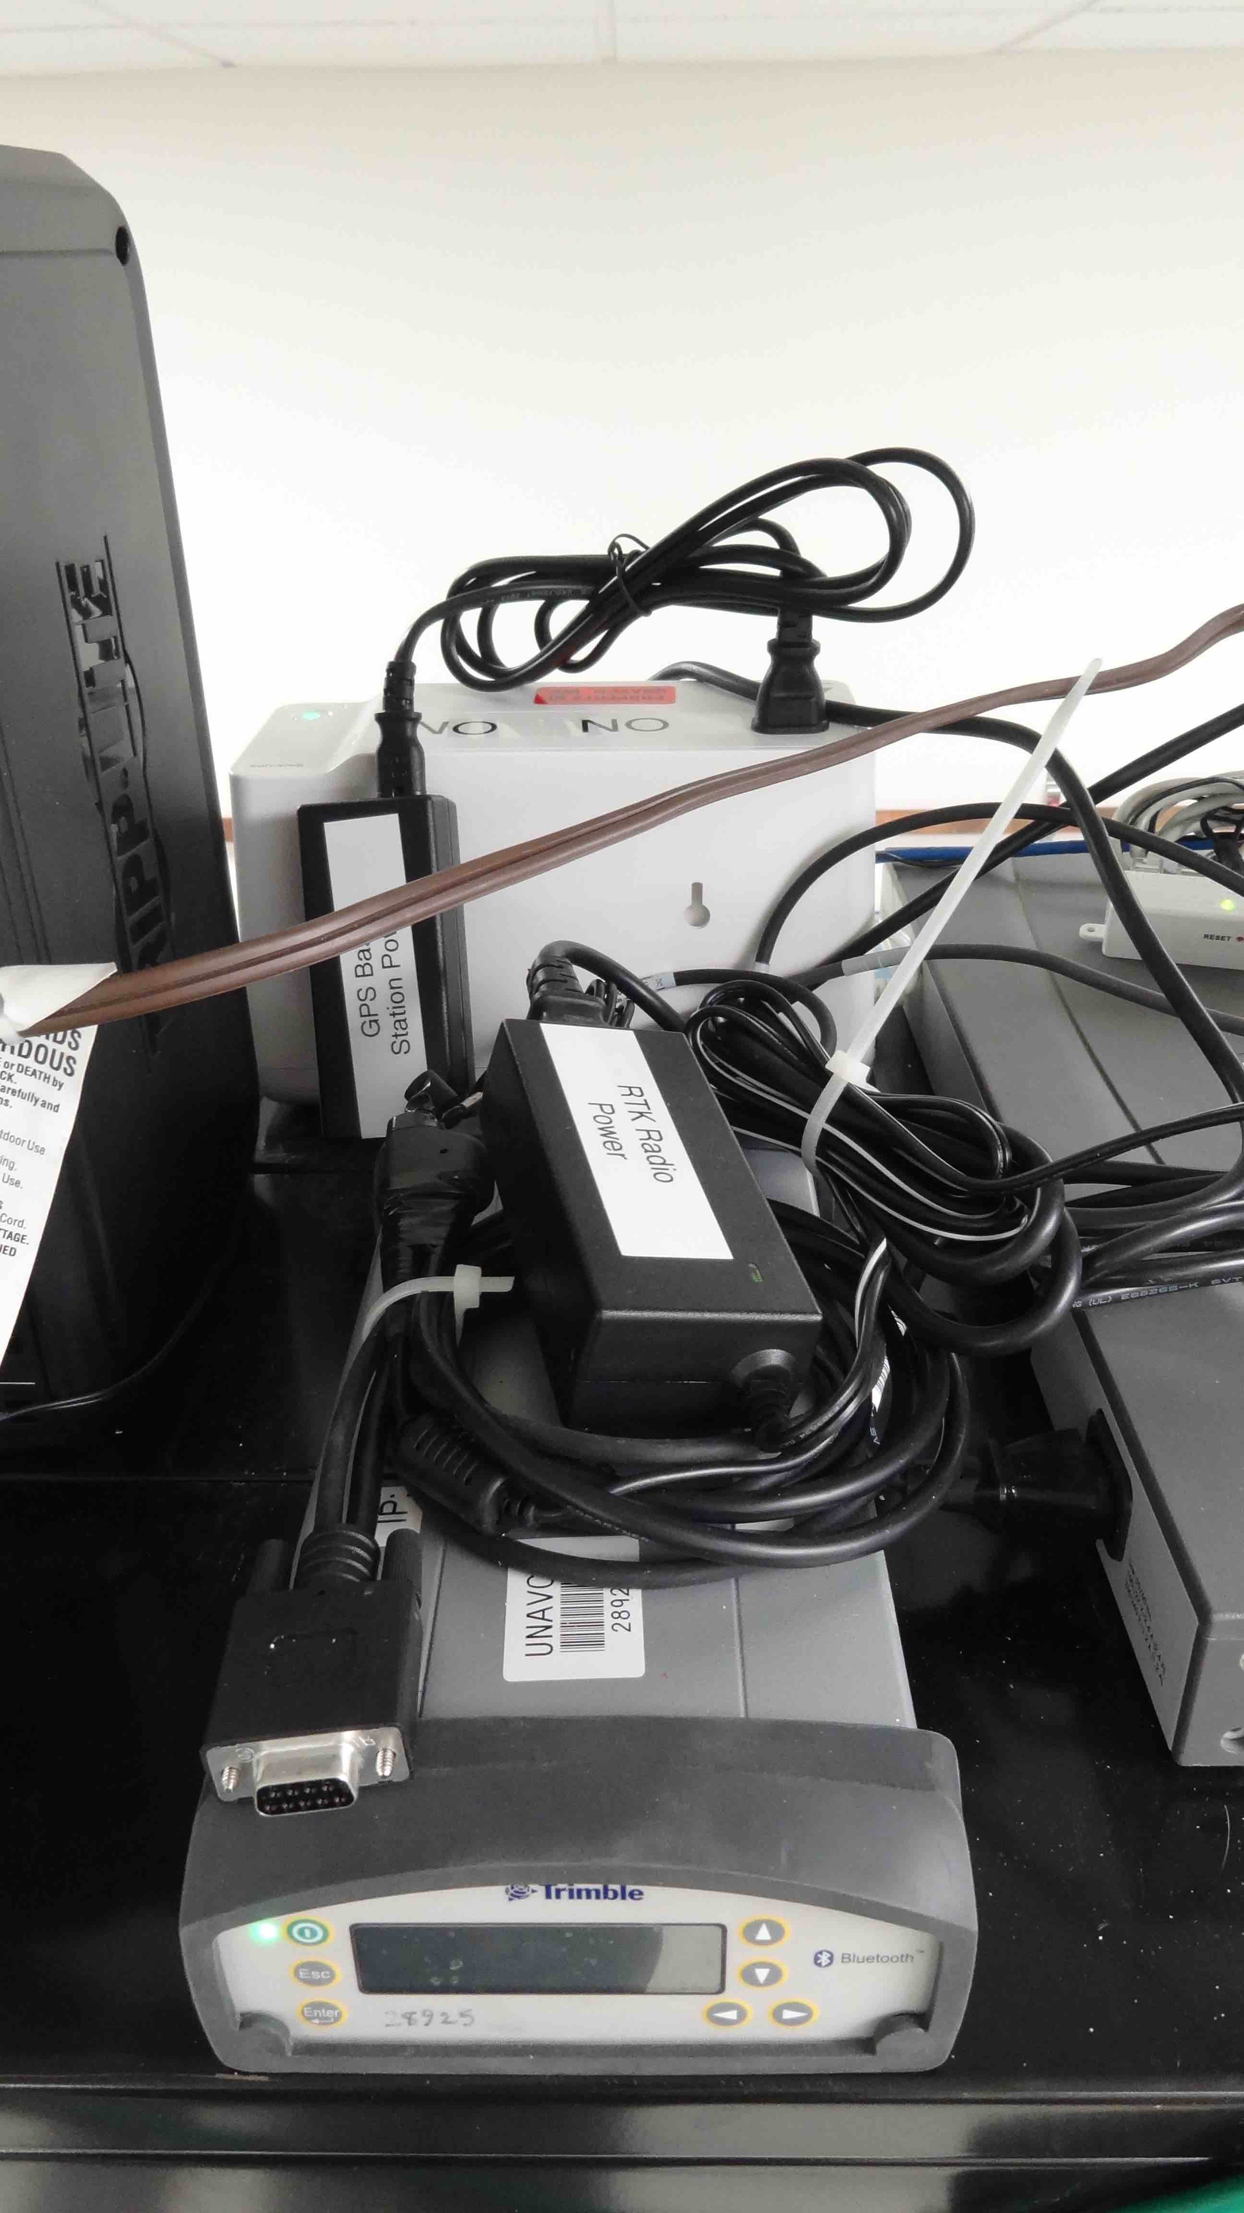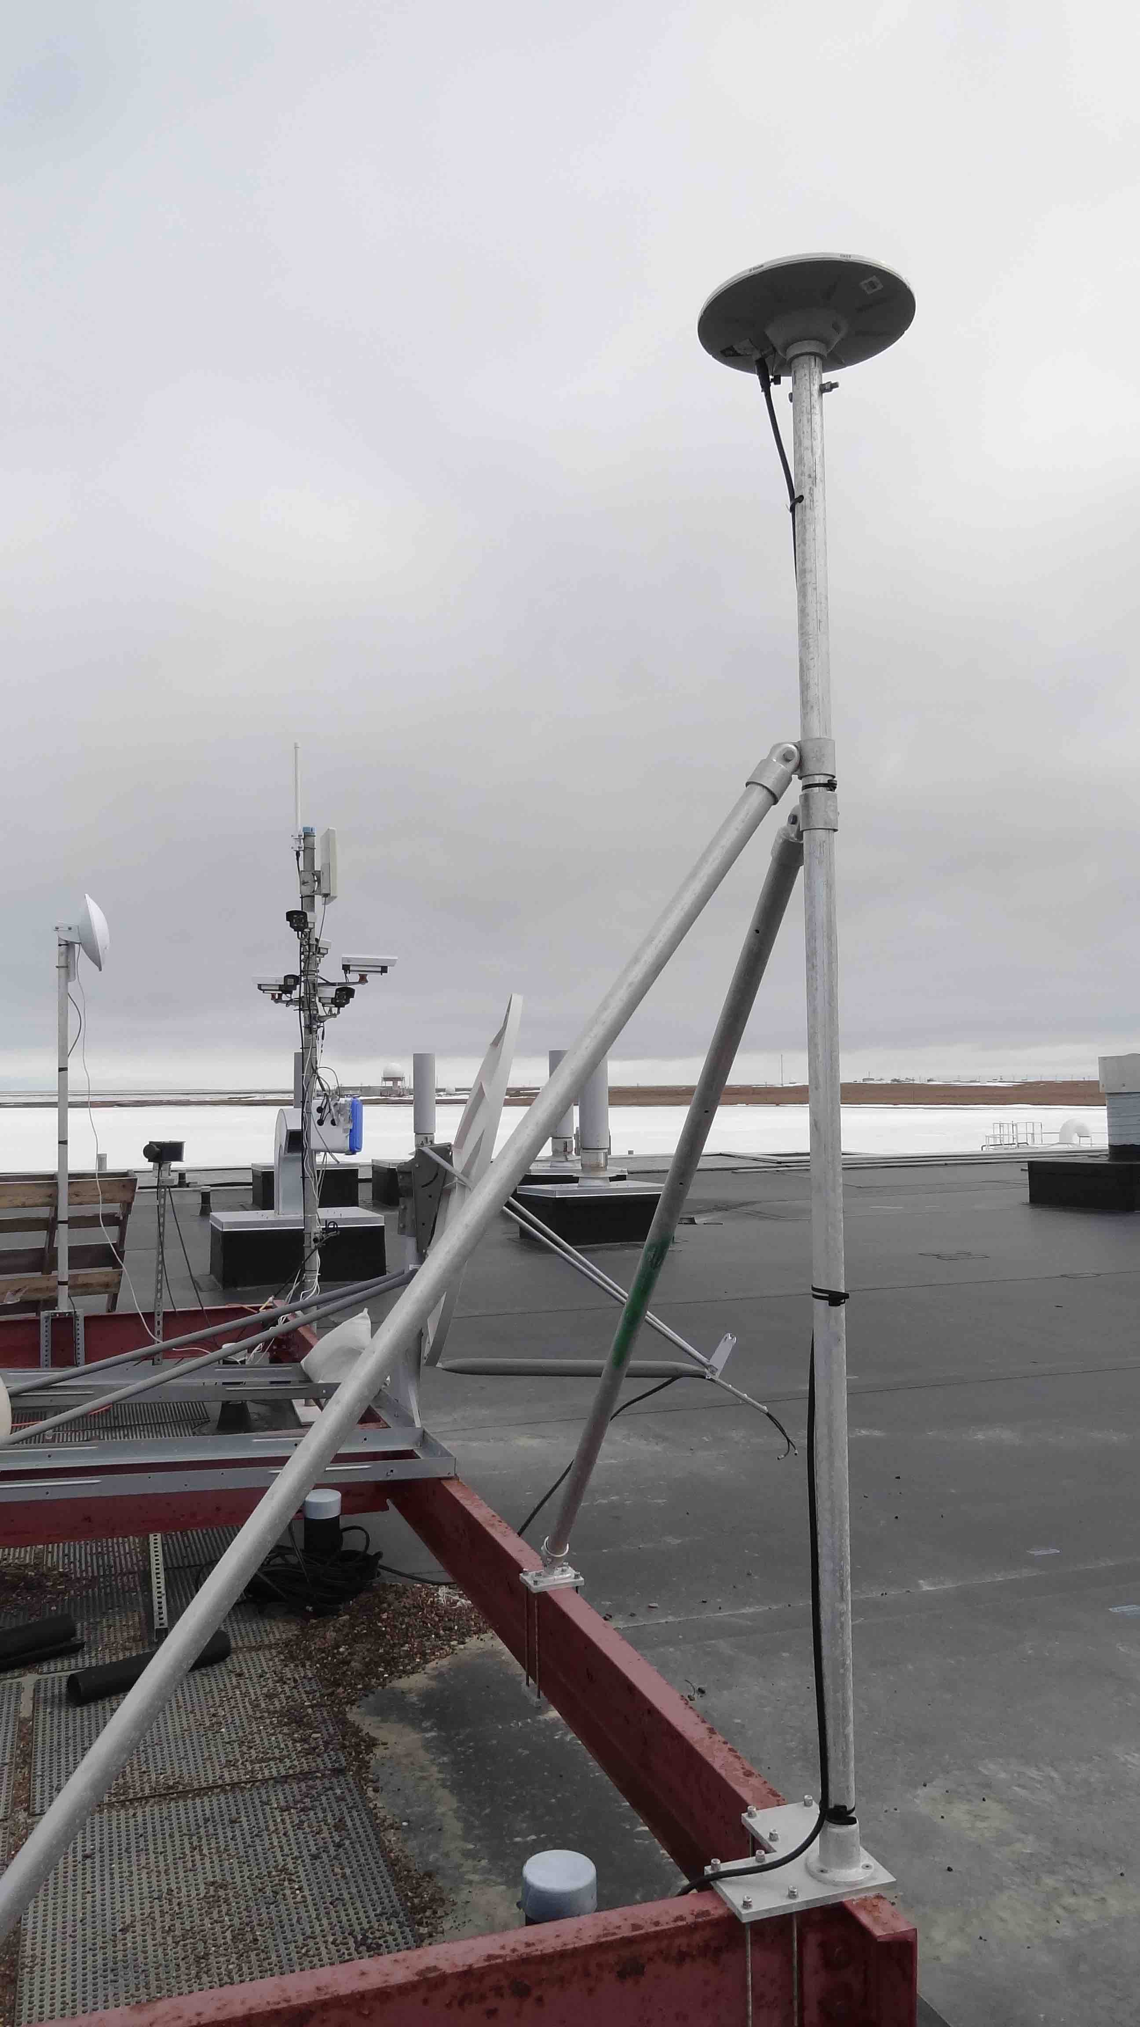
The live base station is located at the BARC building. The base receiver and RTK radio are located in the laboratory 125 of the BARC building, and the GNSS and RTK antennas are on a frame attached to the roof of the building. Data is continuously recorded for post processing, and a real-time kinematic (RTK) broadcast allows local real-time surveys and stakeouts.

This section last updated March, 2016 from http://www.unavco.org/projects/project-support/polar/base_stations_and_survey_systems/barrow/base.html
Item: | Description: | UNAVCO ID #:
GPS receiver | Trimble NetR8 | 28924
GPS power/serial cable | coax power / 9-pin serial / 7-pin LEMO
GPS antenna cable | 30 m, TNC-TNC | 12995
GPS power supply | Trimble | 12965
GPS antenna | Zephyr geodetic | 12999
Radio modem  TURN OFF WHEN NOT IN USE | Trimble HPB450 | 21079
Radio power supply | MW, 120VAC-12VDC, 3A, with 2-pin connector, socket positive | 14031
Radio modem power/serial data cable | Pacific Crest | 21092
Radio modem antenna cable | 18 m, N-N
RF adapter | BNC-N
Radio transmitter antenna | base omni 5dB | 14003

BARO Coordinates, (antenna referecne point): NAD83:
71° 19' 30.17020" N
156° 40' 3.63898" W
11.511m HAE
Note the NetR8 receiver is programmed to record this NAD83 coordinate into the GPS data files.
Orthometric height above mean sea level NAVD88 using GEOID12A:
14.434m

Remote Access
Users at Barrow can download base station data directly from the NetR8 receiver web interface or by using anonymous FTP:
- Online access to NetR8 base receiver http://gps1.barc.alaska.edu
This will bring up the receiver's web interface. The receiver is programmed to allow anonymous access for data download, however if prompted, the username and password are:
Username: dgps
Password: gps
The web interface also allows you to see how many satellites the receiver is tracking, what data files are being logged, and other configuration information. However, you can only download data using this user account and cannot change any of these parameters. Configuration changes are done remotely by UNAVCO using a separate account; contact UNAVCO for any changes or requests.
To download data, next click on the Data Logging tab, then Data Files. Click on the Internal directory then navigate to the directory where the desired files are stored. When you locate the file(s) you want, click on the filename to download. Note that you cannot download any files that are currently being written to. The NetR8 is configured to log files in the following locations:
24-hour 15-second datafiles
/Internal/YYYYMM/24hr15sc/BAROYYYYMMDD0000A.T01
60-minute 1-Hz datafiles
/Internal/YYYYMM/DD/1hr1hz/BAROYYYYMMDDHH00B.T01
60-minute 5-Hz datafiles
/Internal/YYYYMM/DD/1hr5hz/BAROYYYYMMDDHH00C.T01
Each of these file types is allocated a certain portion of the NetR8 memory. When this section of memory is full, the oldest files are deleted. The NetR8 stores approximately 800 days of 15-second data, 60 days of 1Hz data, and 16 days of 5Hz data.
The 15 second data are also available from the UNAVCO data archive (site BARO). Upon request, high-rate data files can be downloaded and made available by UNAVCO, however in general this data is recorded on the receiver only and are not archived. Due to the limited storage space for high-rate data on the receiver, request for archiving high-rate data should be made as soon as possible by emailing archive-gpsunavco.org.
.

Guidelines for Setting up a Temporary Base Station

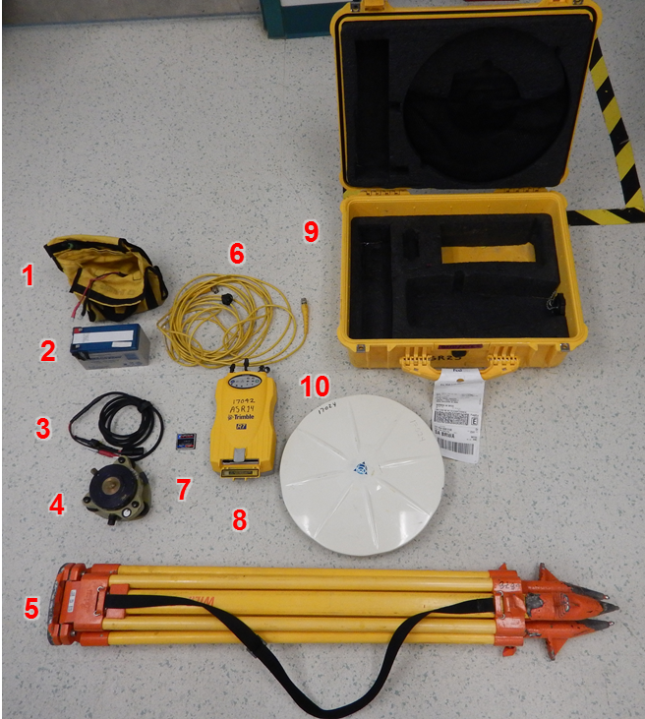
Components

- Brick battery case and terminal connection cable
- Brick battery
- Terminal connecter cable to receiver cable
- Tripod leveling base
- Tripod
- Antenna to receiver cable
- Receiver compact flash card
- Receiver
- Case
- Antenna

Setup
- Setup the tripod and push feet into the ground.
- Attach leveling base
- Using the bubble level on the leveling base as a guide, adjust the tripod legs to get the base roughly level.
- Use the fine adjustment knobs on the leveling base to finish leveling
- Attach the antenna to the leveling base and make sure the tripod is stable
- Connect the straight end of the receiver to antenna cable to the GPS port on the receiver
- Run enough of the 90° end of the receiver to antenna cable from the case’s port to reach the antenna and attach to the antenna
- Attach the terminal connecter cable to the brick battery
- Attach the terminal connecter cable to receiver cable to the terminal connection cable then attach to port 2 on the receiver
- If the receiver does not automatically turn on, press the green power button
- Wait to ensure that the satellite indicator light on the receiver is flashing
- If it’s not check your connections and cycle the power on the receiver
- Shut the case and leave the station running for the duration of your survey and for as long as possible to obtain higher precision location solution (at least several hours)
Close up of the antenna, leveling mount, and tripod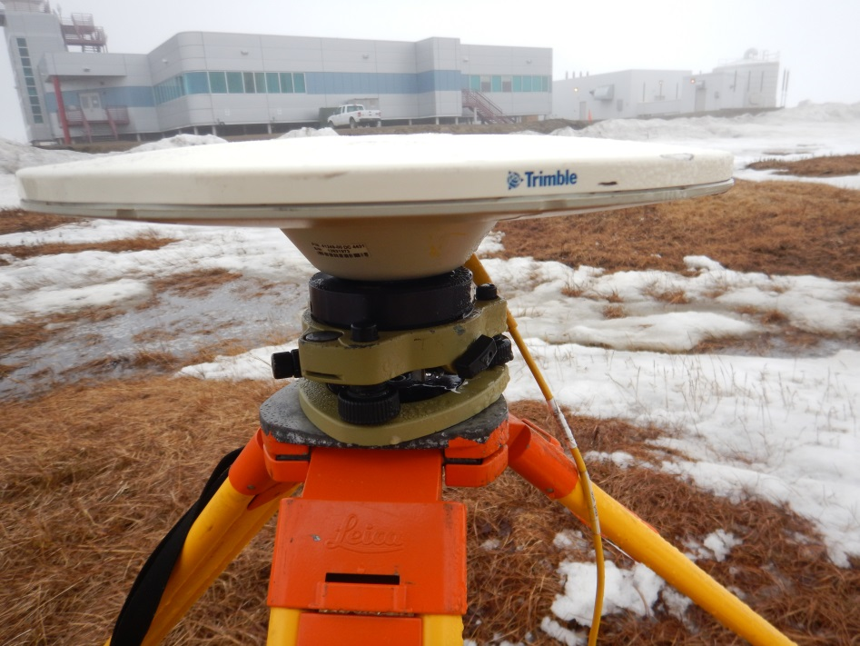
Close up of the brick battery connection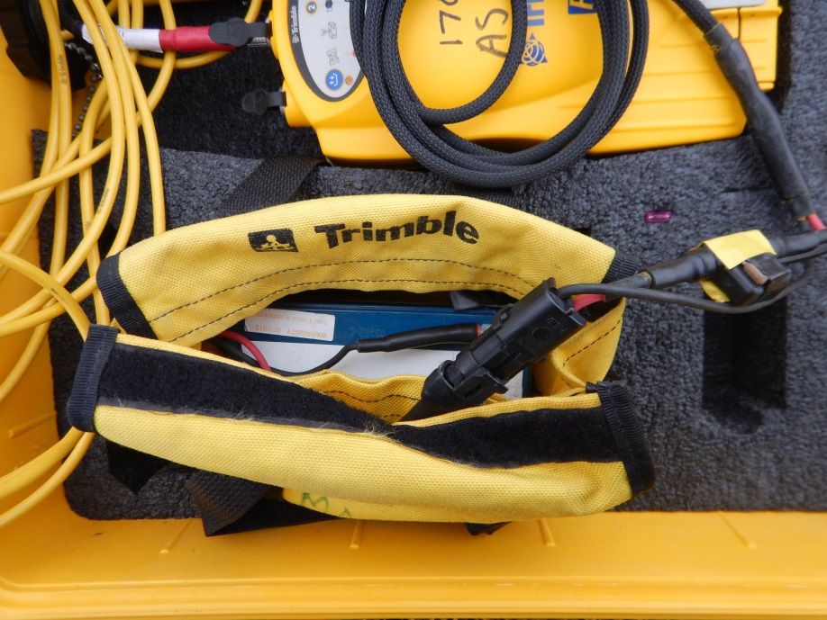
Close up of the receiver in the case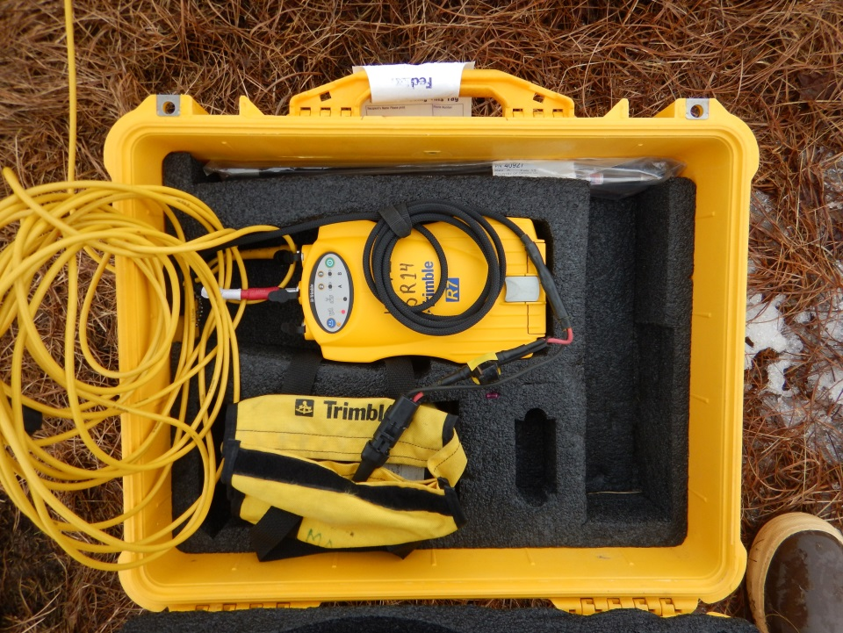
A deployed base station
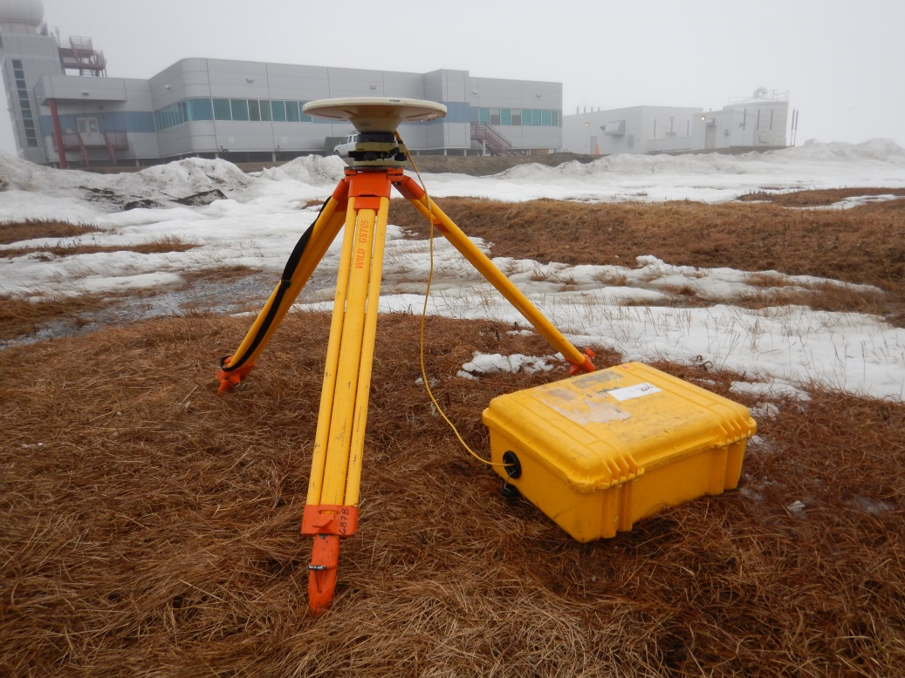

Trimble Rovers

R7 Components and Gear Setup
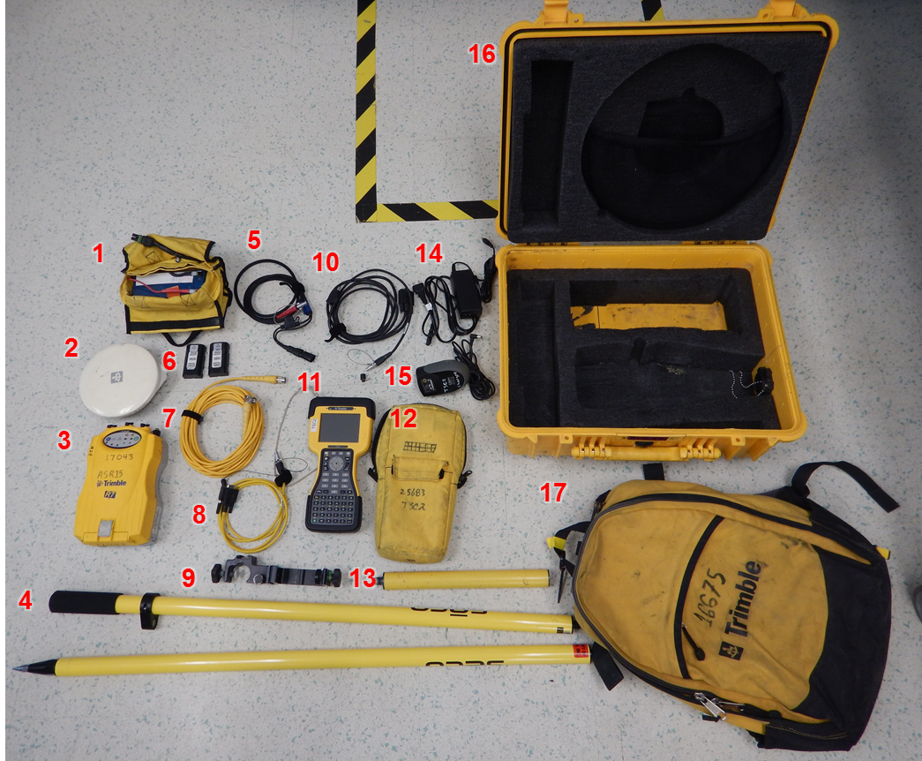
- Brick battery in bag with terminal connecter cable
- Zepher GPS antenna
- R7 receiver
- 2 meter range pole
- Terminal connecter cable to receiver cable
- Receiver internal lithium ion batteries
- Antenna to receiver cable
- Controller to receiver cable
- Controller range pole mount
- Receiver internal battery charging cable
- Controller
- Controller case
- Backpack antenna mounting pole
- Receiver internal battery charging power injection cable
- Controller charger
- Gear case
- Survey backpack
Gear Setup (2 meter range pole survey and internal batteries)
- Put internal batteries in receiver
- Run enough of the 90° end of the antenna to receiver cable out of the backpack so that you will be able to connect it to the antenna on the 2 meter pole
- Run the circular connector of the controller to receiver cable into the back pack leaving the serial cable end out
- Connect the straight end of the antenna to receiver cable to the receiver GPS port
- Connect the round end of the controller to receiver cable to port 1 on the receiver
- Secure to receiver in the backpack using the Velcro straps. Make sure that the cables do not have pressure on the connections and the extra cable is secure. Turn the receiver on by pushing the green power button.
- Close the backpack
- Assemble to 2 meter range pole
- Attach the antenna to the top of the 2 meter pole
- Connect the 90° end of the antenna to receiver cable to the antenna
- Attach the controller range pole mount to the 2 meter range pole
- Attach the serial cable end of the of the controller to receiver cable to the controller
- Attach the controller to the range pole using the controller range pole mount
- Put on the backpack making sure you have enough lose cable to move, but not too much that it can get caught on things.
- Turn the controller on and start the Survey Controller program
- Insure that you are seeing satellites and began surveying

Receiver in backpack with cable runing out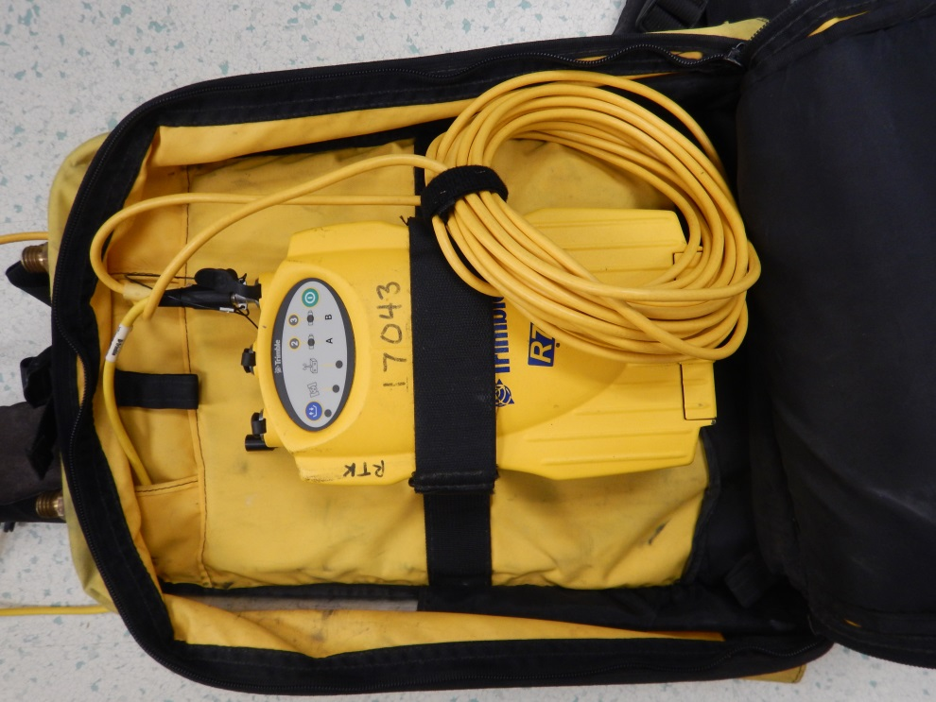
Antena on range pole with 90°end of the antena to receiver cable attached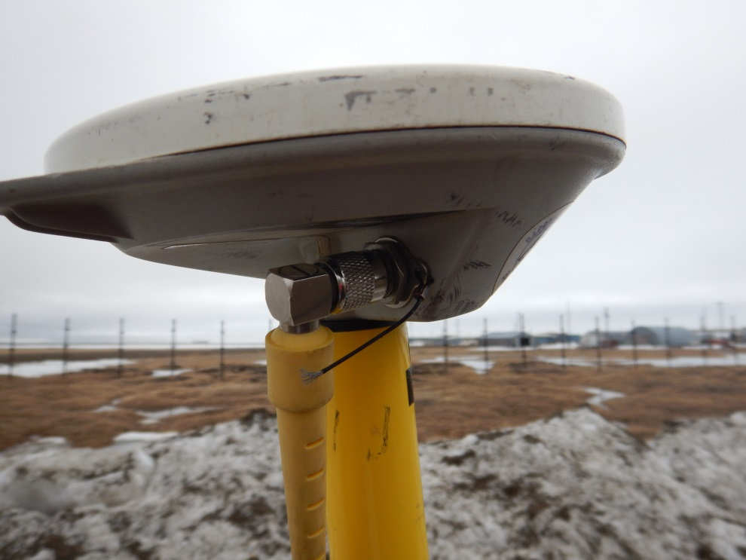
Controller mounted to the 2 meter with the controller to reciver cable attached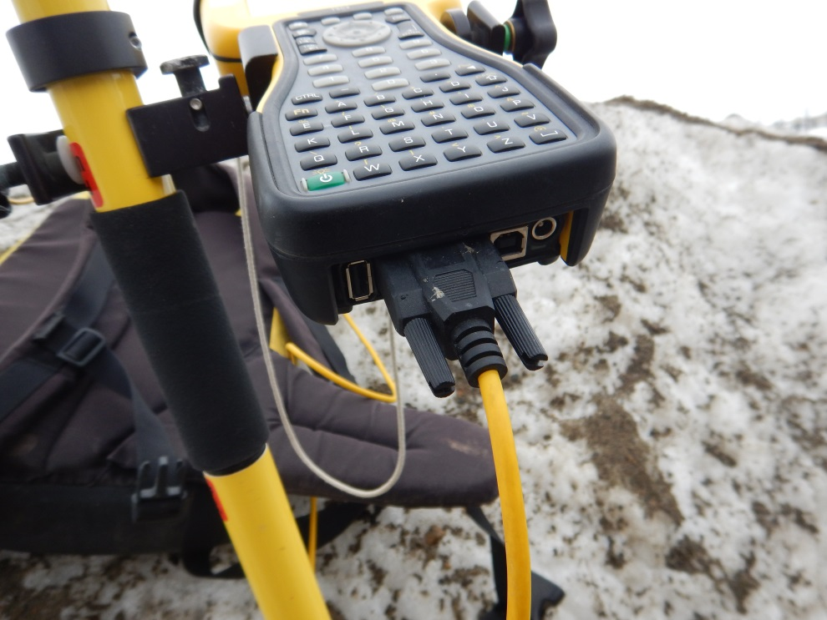
A rover unit set up ready to go
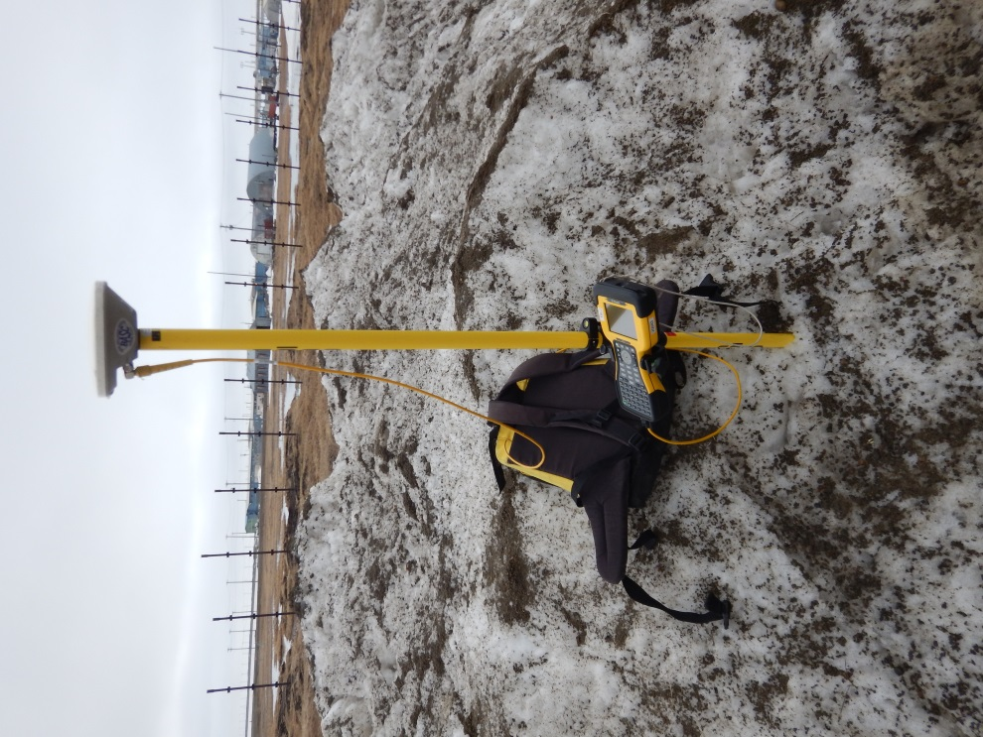

R8 Components and Gear Setup
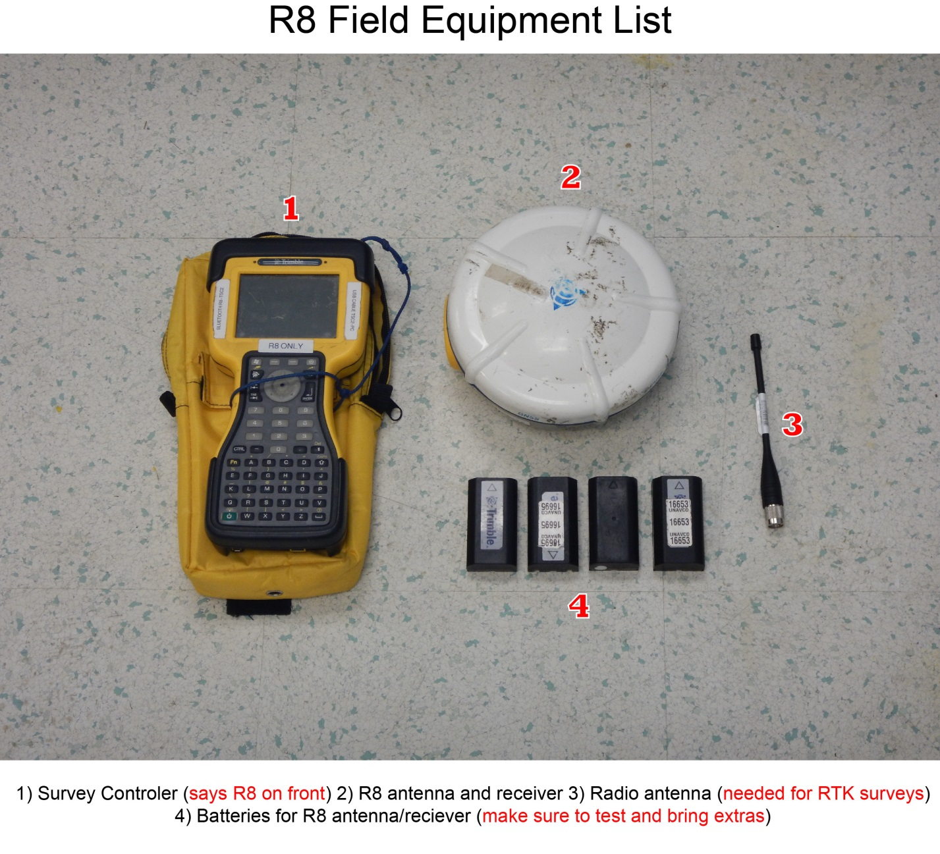

- Put internal battery into receiver/antenna
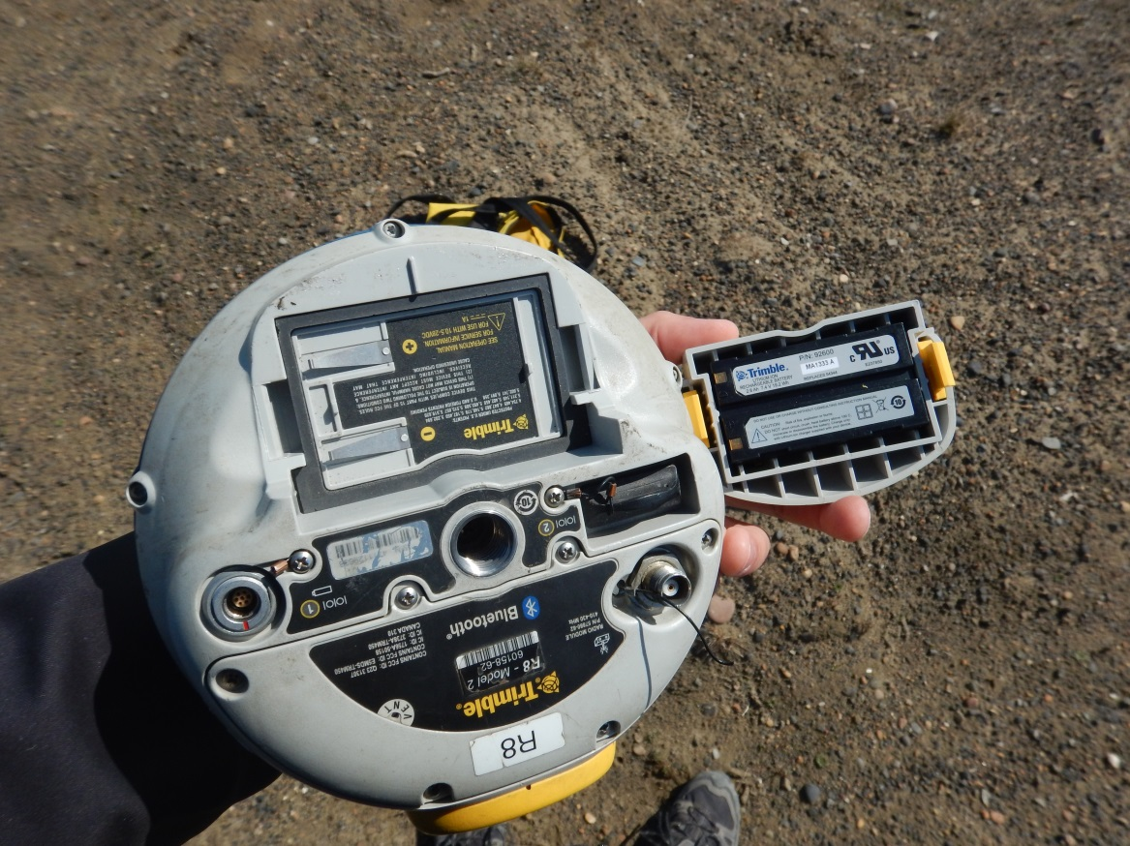

- Assemble 2 meter range pole
- Connect radio antenna to the bottom of the receiver / antenna and place atop the 2 meter
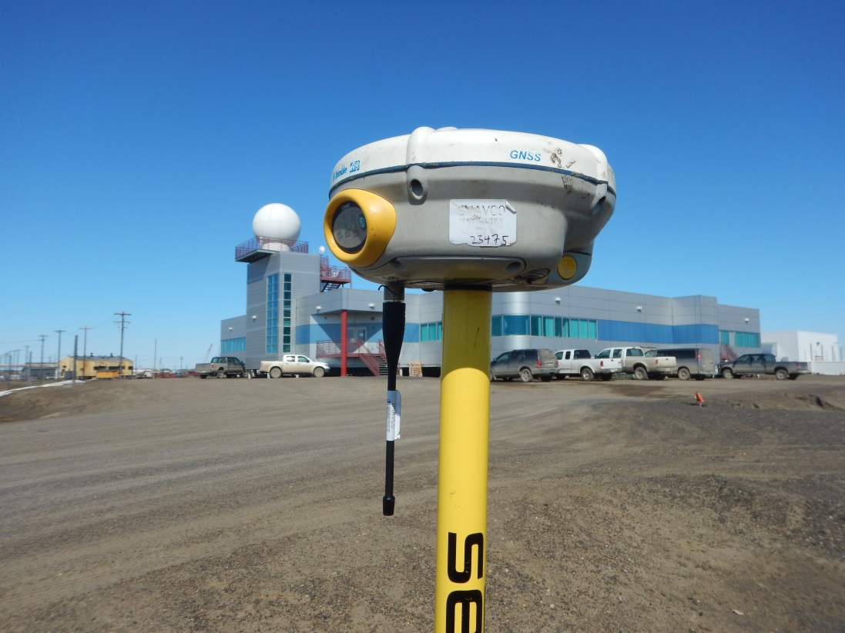
- Press green button on R8 receiver/antenna to turn on the unit. There are three LED lights to the left of the on button. The one to the right will turn green if the receiver is receiving data. The middle LED will turn green if there is a radio link and the left will very dimly flash amber if seeing satellites.
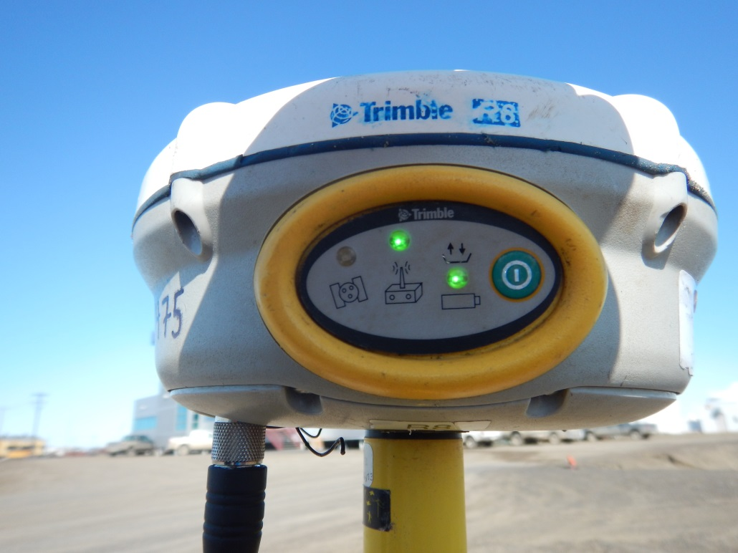

- Turn on the R8 survey controller and press the Trimble logo button.
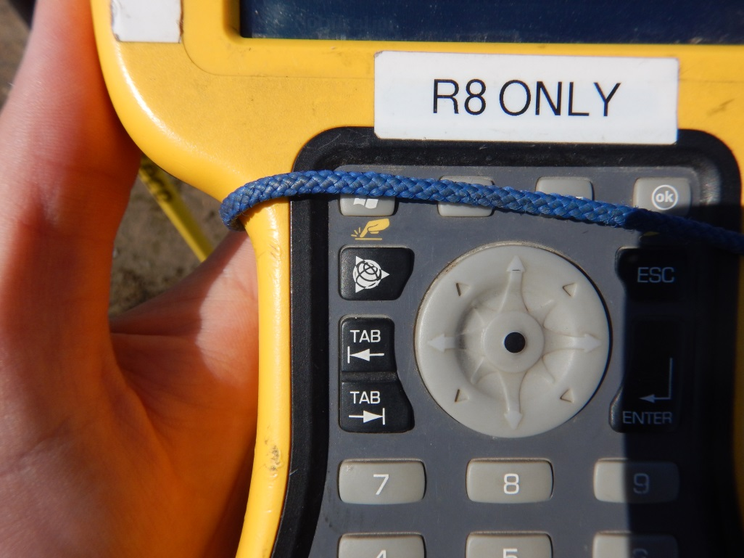

- Your screen in the section to the right will look like the example below if your receiver is seeing satellites and you are connected to your R8
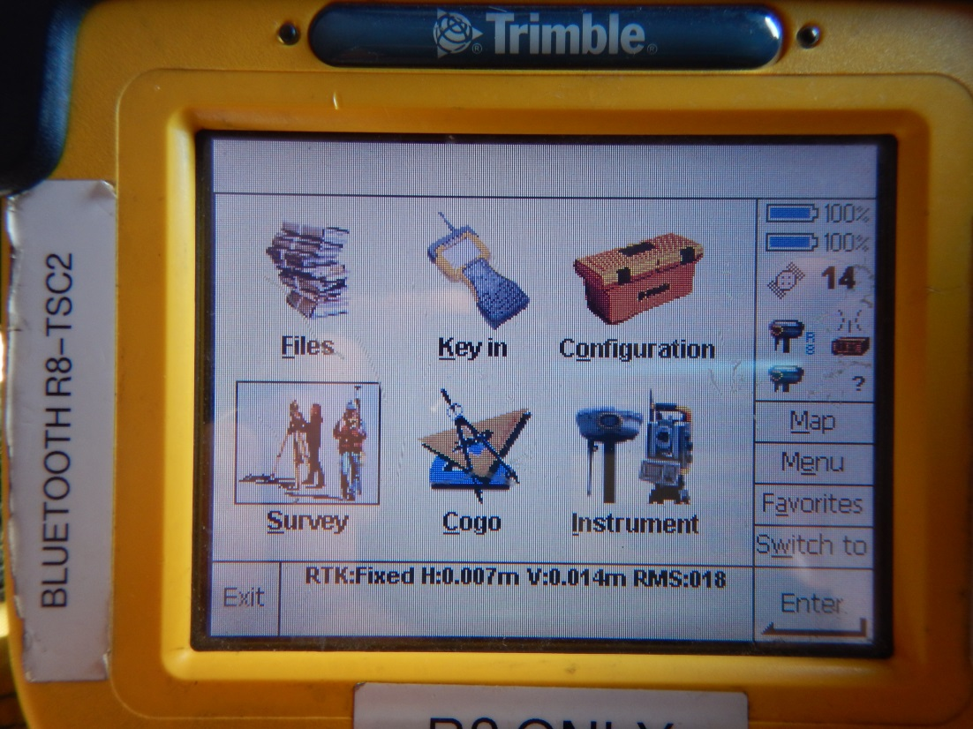

Survey types

Configure the Controller & Conduct a PPK Topo Point or Continuous Topo Survey
This procedure can be used with the survey range pole or backpack mount.
- From the Welcome screen highlight “Survey Controller.”
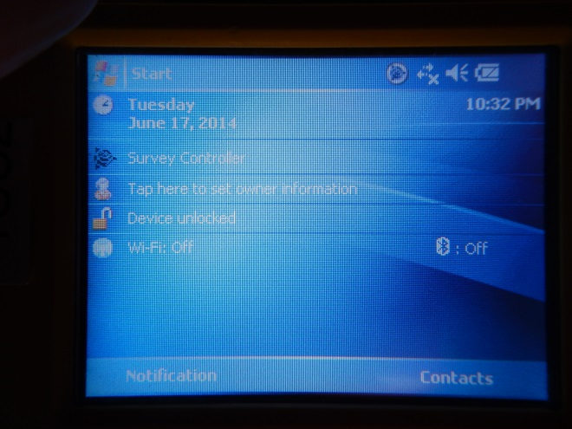
- Click on “Files”
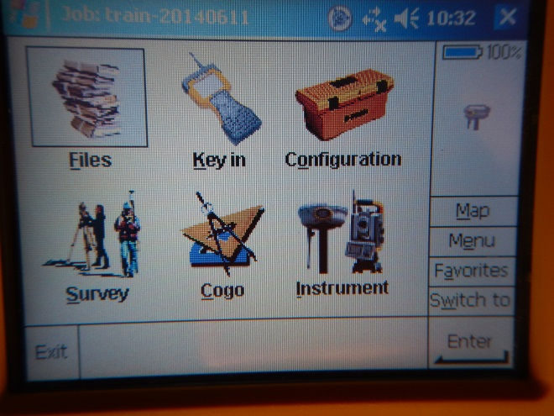
- Select “New Job”
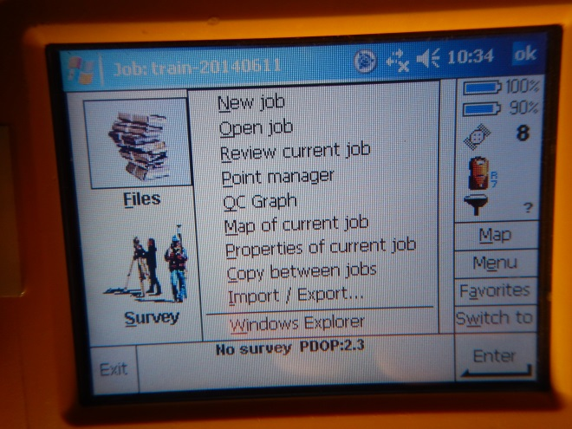
- Give your job a short descriptive name including the date of the survey and click “Enter” and then the “1/2” button to go to the second screen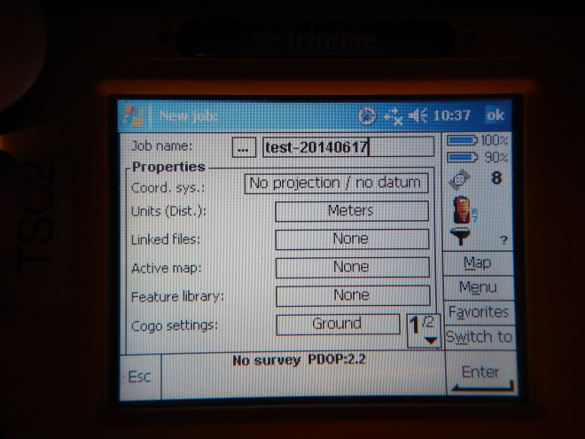
- Enter your initials for the “operator” and hit enter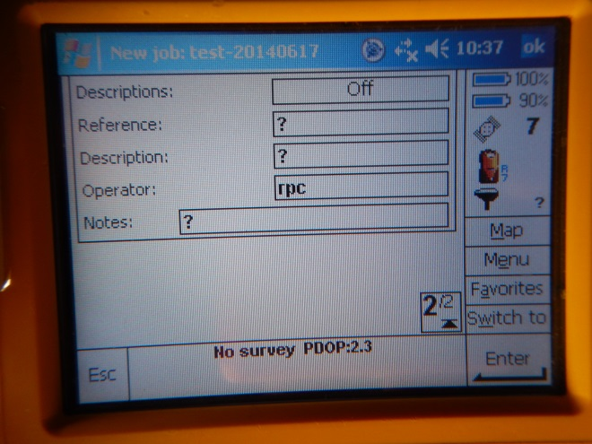
- From the main Survey Controller screen click “Survey” then “PPK”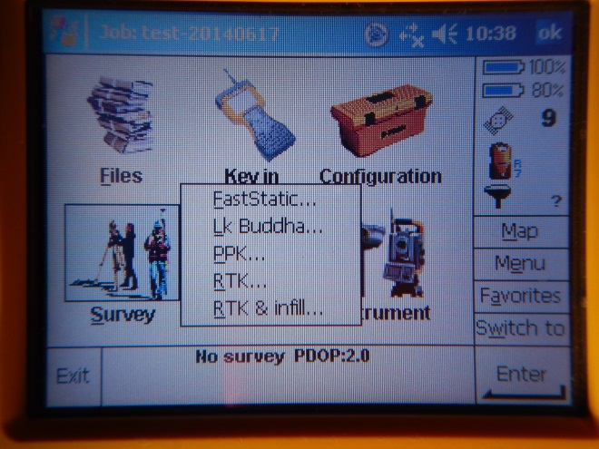
- Then select “Start survey”
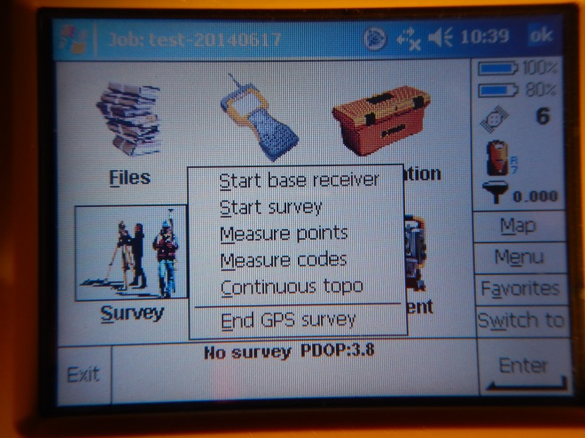
- You will now be initializing (collection a minimum amount of continuous data so you can correct your surveyed points). Initialization times vary by the number satellites the unit is seeing. Under ideal conditions it should be 8 minutes, but could be longer. The bottom of the screen will show you how long you have until initialization is gained. Once initialization has been gained the bottom of the screen will say “Fixed”. If you do not gain initialization, you will not be able to process your surveyed points.
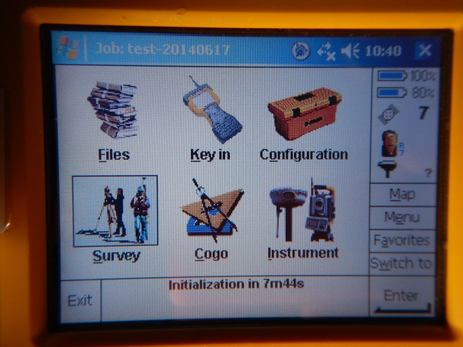
- Once initialization has been gained you can survey points. Click on “Survey” then “Measure points”
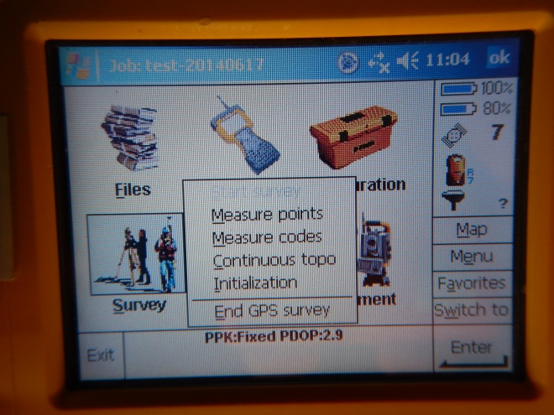
Note: for surveying linear features, you would select “Continuous topo”.
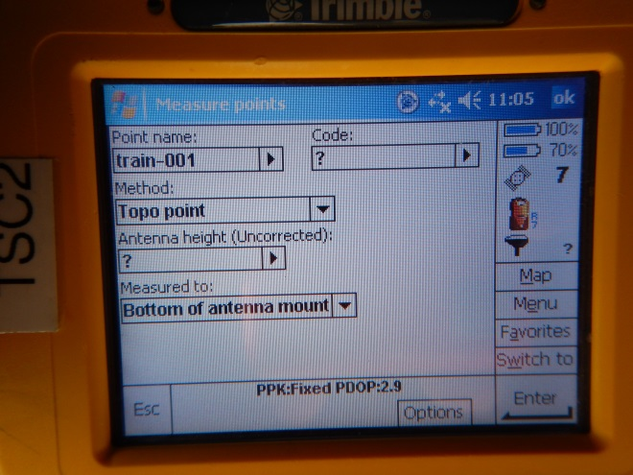
- Enter a name from your first point. Then next point will automatically be named sequentially, so you want to choose a name that ends in 1 with enough preceding zeroes for the number of points you will be surveying.
- Set the antenna height (if using the range pole it should be 2 meters)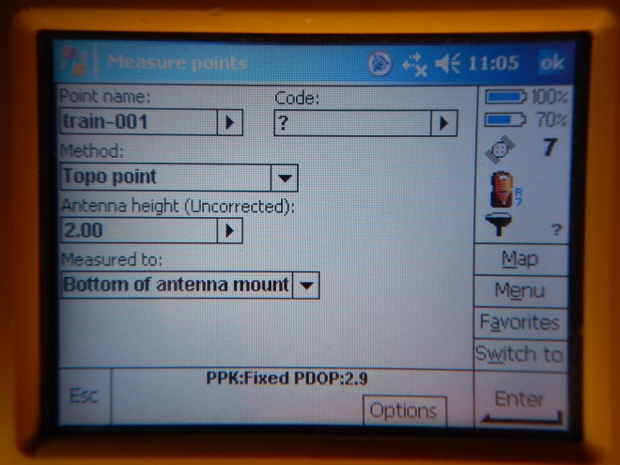

If using the backpack mount (instead of the range pole), you will need to measure the height of the antenna once you are fully dressed and wearing the backpack. In this case, measure from the base of the boot heel to the base of the antenna once mounted.

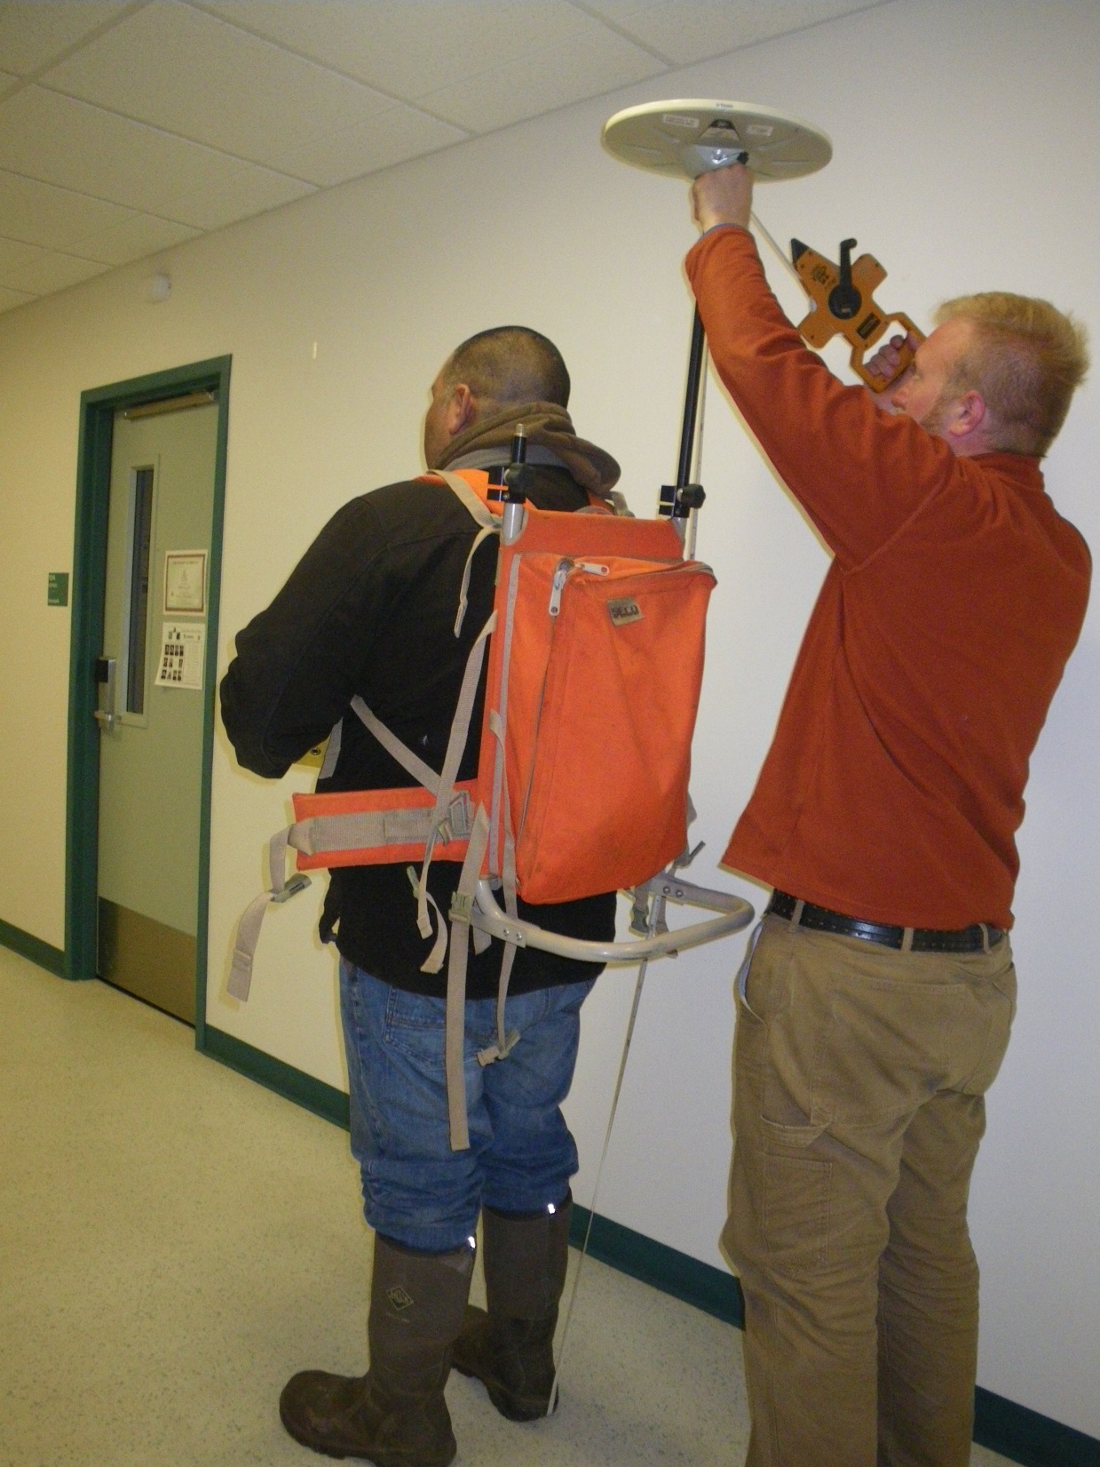
Measure from bottom of heel
Measure to base of antenna
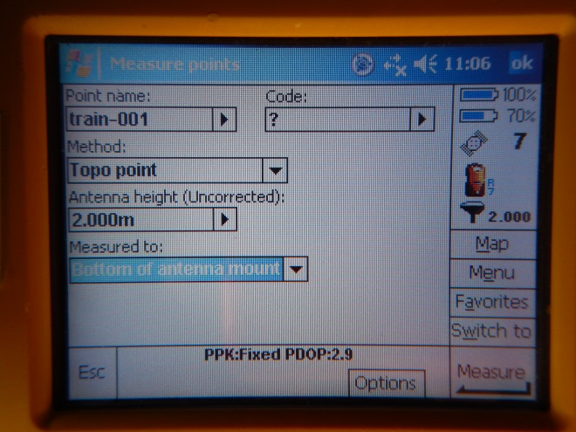
- You are now ready to survey your points. Put the tip of the range pole on the location you wish to survey and use to bubble level on the pole to insure that the pole is level and one you are steady click “Measure”
- You must remain still while surveying the point. The controller will show you how long you have been surveying and how much time is left.
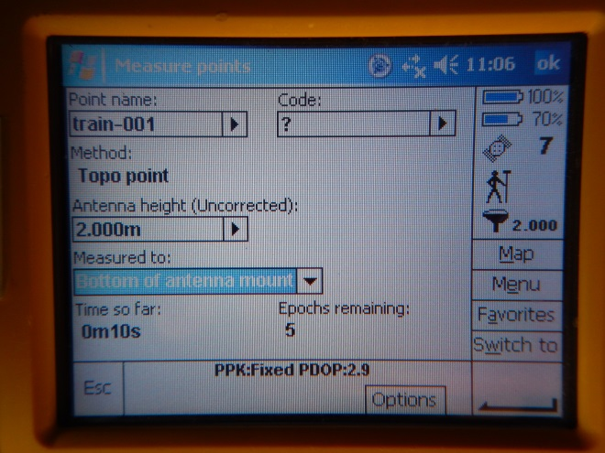
- Once the required time has been reached the point will automatically be stored and the Point name will be incremented. You can now move to your next point.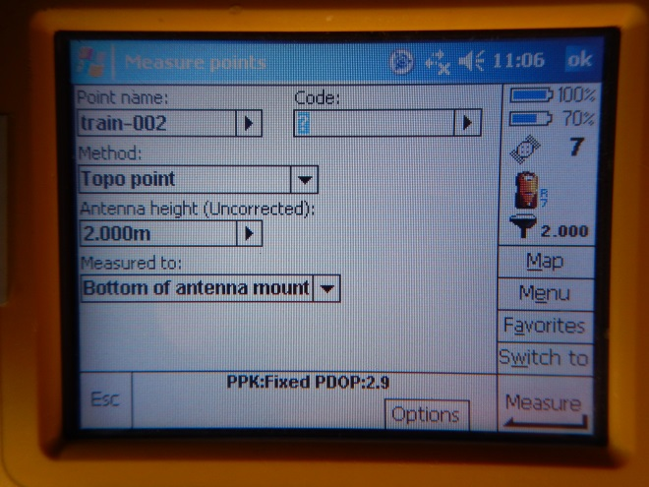
- When finished with your survey click “Esc” to take you back to the main Survey Controller screen then click “Survey” and “End GPS Survey”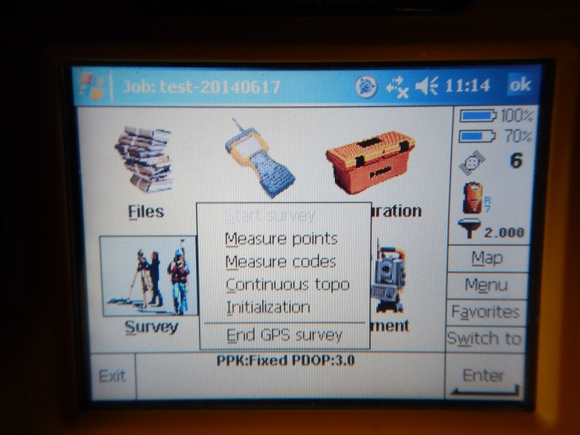
- Choose Yes to power down the receiver
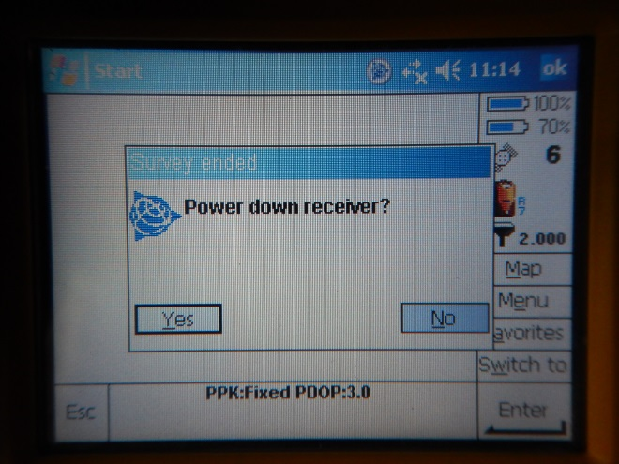
- Click “OK” on the disconnect the cable from the controller message box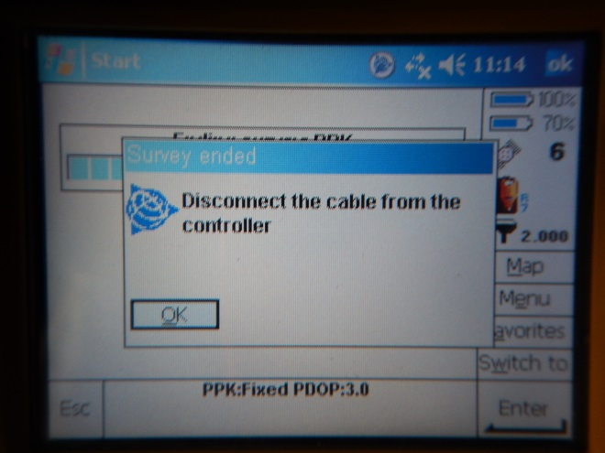
- You can now turn off the controller and disconnect and pack up the GPS gear

Fast Static Survey (FSS)
Note: This section was compiled by UNAVCO for the R7 and has not been reviewed for the R8. Minor differences in the following procedure are anticipated.

Programming the GPS configuration file for fast-static logging:
1. (Optional.) Perform a hard reset of the receiver and format the compact flashcard by
holding the receiver power button down for 30 seconds. CAUTION: Any data on the
compact flashcard will be erased!
2. Connect the receiver to the computer: Serial to LEMO cable from COM2 (Serial com
port on each computer may vary) on the computer to Port 2 on the GPS receiver. Port 2
on the GPS receiver has a computer icon next to it. The receiver must be powered up.
5. Open C-toolbox (Configuration Toolbox).
6. Set comms to COM2: Communications_Port_COM2.
7. Open the appropriate configuration file* in C-Tools: File_Open.
6. Transmit the configuration file to the receiver: Transmit. (Do not hit save before you
transmit.)
7. Double check that changes have been recorded to the new start-up file.
8. Close C-Toolbox.
*one_sec.cfg for 1 Hz logging, unavco.cfg for 15 second logging broken into
daily (24 hour, starting at 00:00 UTC) files.
Static Survey with Receiver Only, no survey controller:
Connect the GPS receiver to the antenna, and to DC power (use internal or external battery). Perform a hard reset of the receiver and format the compact flashcard by holding the receiver power button down for 30 seconds. CAUTION: Any data on the compact flashcard will be erased!
To start the survey, push the green power button to turn on the receiver.
The receiver will go through a self test sequence that finishes with an illuminated green battery LED. At this point the red LED coinciding with the satellite icon will begin to flash rapidly as the unit searches for satellites, quickly settling into a once per second rate. If the LED continues to flash rapidly the system is not seeing adequate satellites. Recheck the antenna cable connections and assure the placement of the antenna is not obscured.
Once the GPS receiver has found enough satellites to create a good solution, the yellow LED coinciding to the blue Data Collection button will illuminate solidly. This indicates that the receiver is logging. It may take some time for the system to begin logging – up to two minutes if the system has not been used in a while. If data logging does not begin automatically, this could be due to the configuration file not having automatic data logging enabled. If you are certain that all other aspects of the set up are fine, press the blue data button to force logging.
Wait about one to two hours. Do not turn off the receiver until the yellow logging light is blinking in tandem with the “tracking satellite” LED. This indicates that data has been collected for an adequate period of time assuming the receiver is within 10kms of the base station. If further afield, more data collection time may be necessary for good solutions.
As rule of thumb for any post-process surveys (static or PPK) is to collect a minimum of 10 minutes of data (20 preferable) for any one point, and to add one minute of occupation time per kilometer of baseline length over 10 kilometers. For example, if you are surveying a point 8 kms from the base station, collect data for a minimum of 10 minutes. If you are surveying a point 28 kms from the base station, collect data for a minimum of 28 minutes.
Push and hold the green button for three seconds to shut off the receiver and end the survey.

Static Survey (FS)
Note: This section was compiled by UNAVCO for the R7 and has not been reviewed for the R8. Minor differences in the following procedure are anticipated.

Static surveys are used to measure the location of a point with high accuracy. Surveys are performed for 10-60 minutes (20 minutes on average) and generally result in positions accurate to <2 cm (Note: accuracy is dependent on baseline length).

Configure the rover receiver using the “Configuration Toolbox” utility. The receiver should log at 5, 15 or 30 second intervals. The receiver needs to be powered up for communications with the receiver.

1.
- Go to the Main Menu and select Configuration Toolbox.
- Click Survey Styles:
- Select the “power_up” file, ok.
“Application file successfully activated” message should appear.
2. Set up and level the antenna over the point of interest and connect the antenna cable, (yellow cable).
3. Connect the other end of the antenna cable to the correct receiver port.
4. To start the survey, push the green power button to turn on the receiver.
5. Once on, you may need to push the blue button to log data if for some reason the logging does not turn on automatically. A steady yellow LED indicates the receiver is logging.
6. Wait 10-60 minutes (longer is better; we recommend 20 min.). Do not turn off the receiver until the logging light is blinking in tandem with the “tracking satellite” LED, this then indicates that the receiver has logged enough Fast Static data.
7. Once the predetermined time is met, push and hold the green button for 3 seconds to shut off the receiver, which ends the survey at that point.
8. Take down the antenna, and move to the next point.
9. Repeat steps 2 through 8 for the rest of the survey locations.

Post Processed Kinematic Survey (PPK)
Kinematic surveys are used to derive positions accurate to within 5-10 cm, while moving. Using the R7 or R8 receiver, Zephyr antenna, and TSC2 survey controller you can perform both Stop and Go as well as Continuous Topo surveys. Stop and Go surveys log data while moving (roving) from point to point then collect accurate point locations (also accurate to 1-5 cm) when in “Static Mode.” The Continuous Topo style collects continuous point locations while moving at the logging rate you select, such as 1 Hz (1 second).
- Connect the controller cable to the receiver (Port 1) to establish a communication link.
- Connect the GPS antenna cable from the Zephyr antenna to the receiver port.
- Turn on the controller, which should also turn on the receiver.
- After a few seconds you should notice the receiver information at the right side of the controller’s main screen, such as the battery meter, satellite information, and PDOP.
- To create a job go to "Files/Job Management" located on the controller display main menu.
- Create "New" or select an existing job. To create a new job, enter a job name and select "No projection/no datum" as the coordinate system, and set “Reference Elevation” to 0.
- Press OK (F1). Then “Esc” to main menu. The job is now set up.
- Choose Survey highlight PPK as the survey style.
- Choose COPY and create a new PPK name that makes sense for the job.
- Choose Edit (F5). Rover Options to edit the configuration.
- Configure as desired- we suggest.
  - Logging device: controller
  - Auto file names: no
  - Logging interval: 1 or 5 seconds (Make sure base is logging at same interval!!)
  - Elevation mask 10-15 degrees.
  - PDOP mask >=6.
  - Antenna type: Zephyr
  - Measure to: bottom of antenna mount.
- Select "Topo Point" and check the options, which may vary depending on your sample rate. Typical settings are:
  - Auto point step size: you choose (usually 1).
  - Quality control: QC1
  - Auto store point: Yes
  - Occupation time: 5-15s, 25 seconds for a logging rate of 5 s.
  - Number of measurements: 3-5 – best if divisible into to occupation time.
- Push Enter Push ESC Push Enter.
- Choose Start Survey Choose Measure Points.
- When you encounter a point of interest-
  - Enter a point name or number and antenna height, if different form last point or default,- then push Measure (F1) or “Enter” to enter static mode.
  - WAIT- DO NOT MOVE!! It is critical to that the antenna does not move while in static mode - from the time you press "Measure" until you receive the "Point stored" confirmation.
- Continue to measure points as appropriate throughout your survey.
- DO NOT end the survey until the survey has initialized, indicated by "PPK=Fixed" on the survey status screen, usually around 8 minutes into the survey.
- Press "Esc", then "End survey" to end the survey. If confronted with an “Abandon Changes” warning message, Always choose NO.
- If asked to “power down receiver,” choose “yes” unless you plan to start a new job.

Real Time Kinematic Survey (RTK)
Note: This section was compiled by UNAVCO for the R7 and has not been reviewed for the R8. Minor differences in the following procedure are anticipated.
RTK surveys provide centimeter level precision coordinates without the need for post-processing. Surveys must be conducted within a 5 km range of the base station unless you plan to use the repeater. If you think you may travel more than 5 km away from the base or lose line of sight communication with the base, choose “RTK and infill.” When using “RTK and infill” the base broadcasts 1 sec corrections, and logs data at 5 sec intervals, unless set to log at 1 sec (see manuals for details).
- Connect the survey controller to the GPS receiver (Port 1) and set it up on the range-pole, or in the backpack. If using a TSC1 controller instead of a TSC2, there is a removable memory card in the side port. Everything should be written to this. The TSC2 as plenty of internal memory.
- Turn on the controller, which also powers up the receiver.
- Select "Files/Job Management" on the controller display main menu.
- Create "New" or select an existing job. To create a new job, enter a job name and set “File Location” to "PC card". Select "No projection/no datum" as the coordinate system, and set “Reference Elevation” to the local average.
- Choose survey RTK.
- Choose edit (F5) Rover Options.
- Set up should look like this (modify if needed)
Survey type RTK
Broadcast format CMR+
WAAS off
INS positions RTK only
Use station index any
Prompt for station index no
Elevation Mask 13 degrees
PDOP Mask 10 (or lower for greater accuracy)
Antenna height ? (Set to measured height)
Type Zephyr (Zephyr Geodetic).
- Choose Topo Point and configure
  - You choose step size (usually 1)
  - Quality control: QC1&QC2
  - Auto store: yes
  - Occupation time: 5s
  - Measurements: 5
  - Choose precisions for auto store. (e.g. 0.015 m horizontal 0.02 m vertical)
- Choose precisions continuous points if you like.
  - Continuous data is logged as long as precisions are met.
- Push Enter Push ESC Push Enter.
- Choose Start Survey Choose Measure Points.
- When you encounter a point of interest-
  - Enter a point name or number and antenna height, if different from last point or default setting- then push Measure (F1) to enter static mode.
- WAIT- DO NOT MOVE!! It is critical to that the antenna does not move while in static mode - from the time you press "Measure" until you receive the "Point stored" confirmation.
- Continue to measure points as appropriate throughout survey.
- DO NOT end the survey until the survey has initialized, indicated by "RTK=Fixed" on the survey status screen.
- Press "Esc", then "End Survey" to end the survey. If you encounter an “Abandon Feature” warning, choose NO
- If asked to “power down receiver,” choose “yes” unless you plan to start up a new job.

RTK Stakeout Surveys (Equivalent to navigating to waypoint)
RTK surveys can be used to find or return to a specific point.
- Choose Survey (the survey which contains the points you need to navigate to) > RTK > Stakeout
- Choose Points > Add
  - To navigate to a point already in the job, choose “Select from List” then press Enter
  - To navigate to a pre-determined point, carefully flow the directions below.
- Navigate to the point using the display. In ‘coarse mode’, walk forwards at a normal pace
being careful not to rotate the range-pole. The arrow won’t tell you which way to walk
until you are in motion.
- When you are close to the mark, the screen switches into ‘fine mode’ with a bulls eye to
center the antenna over the mark. At this time, remain pointing in the same direction; do
not rotate your body and move slowly towards the mark. If you pass the mark, walk
backwards. Do not turn to move left or right, rather, step sideways.

Stakeout Survey with previously Determined Points
Should you have a set of points that you need to return or navigate to, use this option.
- Create a comma delimited text file (file.csv) with the following format: Name, Northing, Easting, Elevation
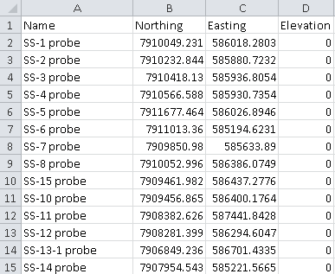
(If you don’t have elevation data, enter zero.)
- Open a new job in Trimble Business Center and choose the “BAID Barrow UTM” project template. (If you haven’t made this project template follow the steps in this manual)

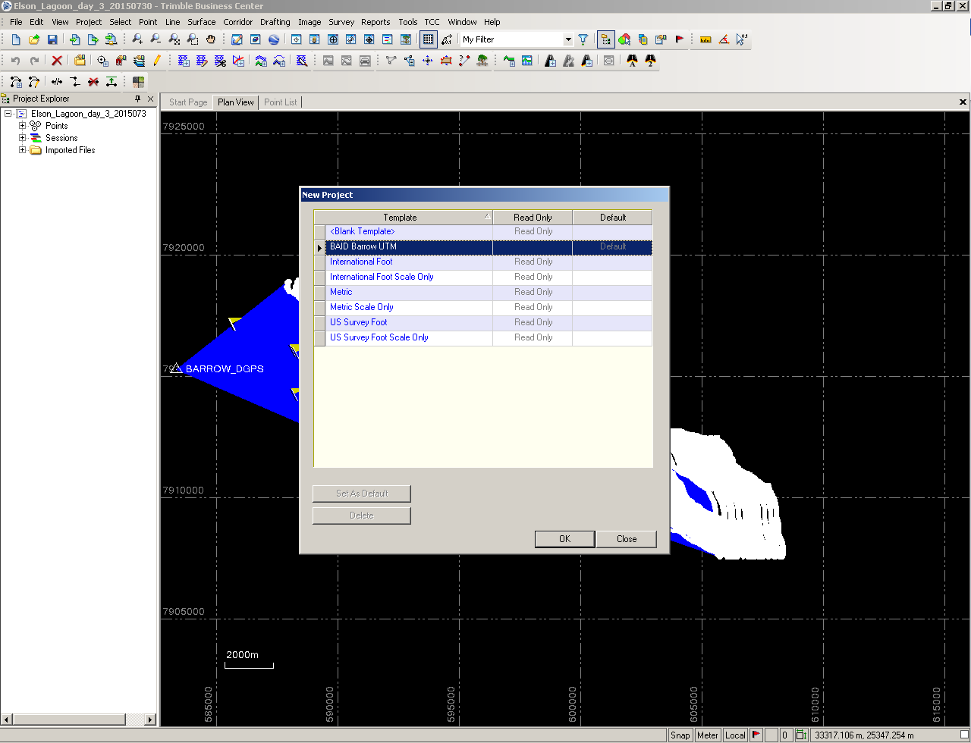
- Import and navigate to the folder where your new csv. Is located. This will open the “Import Format Editor” window.
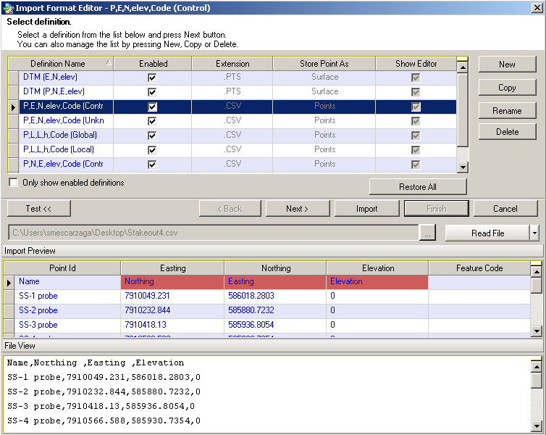
- Choose the Definition Name “P,N,E,elev,Code(Unknown)” in the top scroll-down menu then click “next” twice.
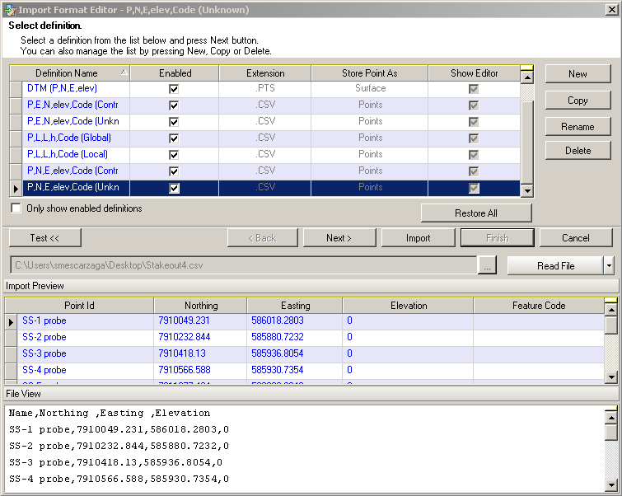
- This will take you to the “Select general properties” menu. Make sure all the properties match the image below. Then click next, then import.
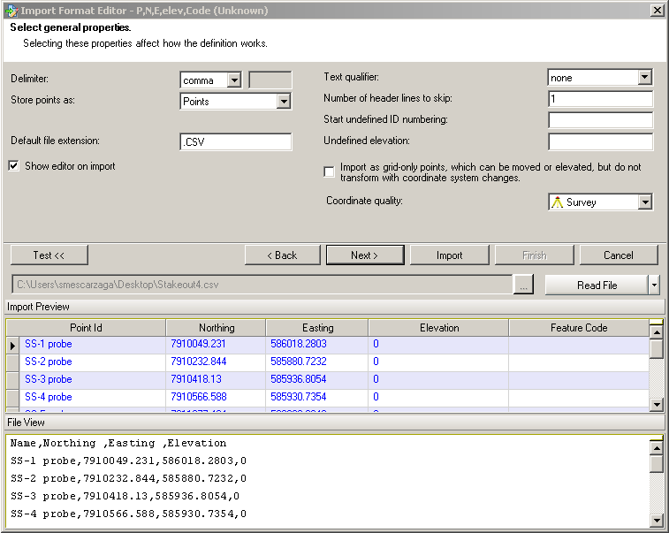
- Your points should now show up in the project area. Now it’s time to export these points into your survey controller. Click export , select “Survey” from the “File Format” menu. Then choose “Survey Data Collector (DC) exporter” in the scroll-down menu. Click “Options” just below that and choose “select all”. Choose your file name and folder destination then click export. NOTE: the file name should be no longer than 9 characters.
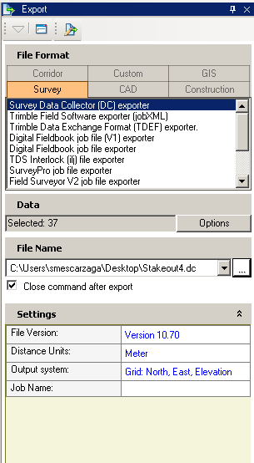

- Connect your survey controller to your computer via the USB port (instructions elsewhere in this manual.)
- Next, launch the “Data Transfer” software for Trimble devices.
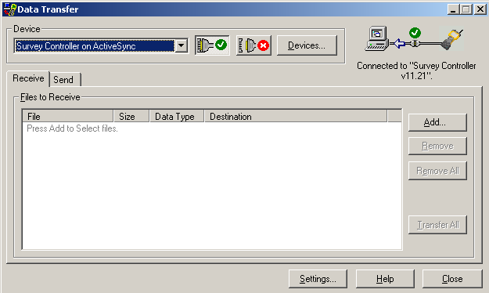
- Your connected device should be “Survey Controller on ActiveSync” as seen above. If it doesn’t exist in the drop down menu, you’ll click “Devices”, click “new”, then choose that name in the scroll-down menu.
- Since we are sending data to our controller, we’ll need to click on the “send” tab. Then click “add”. Choose the dc. File you’ve just exported from Trimble Business Center.
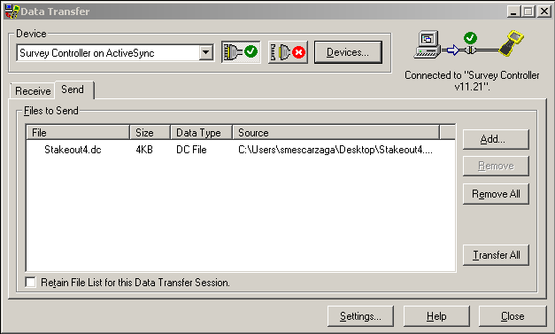
- Next click “Transfer All”.
- On your controller, open the “Trimble Survey Controller” software by pressing the Trimble button.
- From the main menu, click “Files” then choose “Open job” in the drop-down menu.
- Scroll down and find the file you just uploaded to the controller and click it. The controller will give you a warning stating a project height is required. Click “ok”.
- This will take you to the “Key in parameters” screen. Click “Projection”
- If using a projection other than UTM zone 4 (same as the BAID Barrow UTM project template) key in them here. If points are in Barrow and you used that project template, make sure you key in the parameters show in the images below.
- Then click the “Vertical Adjustment” menu, choose “No adjustment” for “Type” and accept. Then escape.
- Your stakeout survey job is now ready to begin. Next we’ll go through setting up the RTK and navigating to points.

Collecting Ground Control Points (GCPs)

Guidelines for Collecting Ground Control Points
For Barrow CIAP Project, Fall 2013 (Bill Manley, 9/16/13)
INTRODUCTION
Collecting Ground Control Points (GCP’s) using DGPS for use later with georeferencing and orthorectification of imagery is both a science and an art. What follows are some guidelines, tips, and tricks.
In general, it can be important to have carefully measured GCP's to help with:
1) orthorectification of imagery;
2) independent quantification of errors in orthorectified imagery.
FINDING A PHOTO-IDENTIFIABLE FEATURE
First, while in the field, the scientist finds a "photo-identifiable feature" -- in other words, a small distinct natural feature or manmade object that will be clearly visible in the imagery of interest. In general, if working with 1.0 m or better imagery, it works well to survey: ends of snow fences, intersections of pipelines, base of one side of telephone pole (often the pole shadow is visible in high res. imagery), the corner of structures that are low to the ground, bridge abutments, discarded oil drums, etc. It can also be ok to measure the corners of buildings (but use the base, not the roof, to avoid issues with layover; and to make sure we can see it in the imagery, survey two opposite corners). Natural features can be ok if they are distinct, as well as STABLE through time (don't use the coastline!); examples include the center of very small islands in ponds, or the center of very small ponds, the ends of very large driftwood, small boulders, or other features that are about 1-2 m across -- as long as they could be uniquely identified in the imagery. Creek intersections can be ok also, but might have shifted through time. It’s best to avoid natural features.
It is extremely helpful to have the actual imagery, or comparable imagery, in the field with you. In this way, on a printout or in a computer, you can more easily find and document such features.
IN THE FIELD WITH DGPS
Then the scientist uses DGPS to measure the precise latitude and longitude of the feature. For use with high-resolution imagery (<= 1 m), there is limited benefit to working with handheld GPS units (e.g., Garmin) that have errors now of approx. +/- 5 m. In general, it is important to use Differential GPS units (ie., Trimble) that have errors <1 m, and can be as low as 2 cm. Make sure to note the horizontal datum (ie., NAD83 or WGS84, etc; as well as vertical datum if recording elevation).
Finally, it is important that the scientist document the GCP's carefully, so that they can be found accurately in the imagery. This should include careful notes, as well as photographs taken in the field from several perspectives (noting, for example, that a given photo was taken "looking southwest" etc). Also, if at all possible, it would be important to actually mark the locations of GCP's on any available high-resolution imagery (ie., on a 11x17 printout, or with safety pin on air photo prints, or in computer, etc). Then the "metadata" for the GCP's can be pulled together such that a technician can zoom into the high-res. imagery, identify the feature, and enter the coordinates or measure offset (error).
As an aside, an even better way is to have panels (e.g., white-painted plywood sheets in a cross) placed and surveyed on the ground BEFORE imagery is acquired. In that way, the feature can be very precisely located in the imagery.
REVIEW GCP DATABASES
Finally it might help to review one example of an online GCP database, such as the one we put together for Barrow, with some descriptions and marked-up photos:
http://instaar.colorado.edu/QGISL/barrow_gcp/. And also see the BAID GCP database (http://baid.utep.edu).

Helpful Form for Collecting GCPs

BAID GCP ID: ______________
Start with BAID456 then continue with BAID457, BAID458, etc.
DGPS Controller ID: ______________
If different from above.

Acquisition Date: ____ / ____ / ________
The date that the new GCP was surveyed in the field, as mm/dd/yyyy.
Acquisition Time: ___________ am / pm
Recording the time when photos were taken will help tie the photos to the appropriate GCP.
Acquired By: _______________________________________________
Who filled out this form, took pictures, and did the surveying.
Feature Type: __________________________________
Building, pipeline, snow fence, boardwalk, bridge, oil drum, other, …
Description: ______________________________________________________ ____________________________________________________________________________________________________________________________________
A phrase or sentence like “Intersection of pipeline and snow fence NE edge of UIC-NARL complex, near Imikpuk Lake”, or “SW corner of Welding Materials Technology building, NARL”, or “SE corner of wooden platform, NW edge of Imikpuk Lake, near NE corner of UIC-NARL complex (across lake from DEW line "golf ball" dome)”.
Antenna Height: _______________
Measured height of the antenna above ground (note if different than above ground), in meters.
Survey Duration: _______________
How long the static point was surveyed. E.g., 10 min, 22 min, etc.
Feature Scale: _______________
An estimate made in the field of the aerial extent of the GCP feature. For example, the sharp corner of a building can often be defined within 2 cm, whereas a road intersection lacks a precise, definable or identifiable point, and can be resolved in the field, and on imagery, only to about 2 m. E.g., 0-2 cm, 10-20 cm, 0.5-1.0 m, etc. This parameter is also called “Point Resolution”.
Comments: ______________________________________________________ ________________________________________________________________________________________________________________________________________________________________________________________________________________________________________________________________________

Steps for Collecting GCPs

Before the Field
- Clarify needs
- Identify targets features to survey identified from imagery, maps, previous knowledge, etc.
- Make field travel plan
- Get field gear ready
- Charge and organize the DGPS equipment
In the Field
- Find the feature
- Set up the antenna and survey pole with bipod legs
- Start the “fast static” survey
post-processed static point, with stationary antenna; survey for one minute per km from the base station, with a minimum of 10 minutes, and preferably at least 20 minutes; e.g., 10 min for 2 km from base station; 32 min for 32 km from base station.
- Fill out the form
- Take pictures
2-5 photos with the antenna in place, from a variety of angles
- When done, take down the equipment and move on
In the Office Afterward
- Enter the field information etc. in the template spreadsheet
filename: “baid_new_GCPs_yyyymmdd.xls”; e.g., “baid_new_GCPs_20130922.xls”
- Enter the filenames for photos, and .job file, etc.

Post Processing Using Trimble Business Center

Folder structure
Create a folder named after the job file you created in the Trimble controller. Adopting a convention which incorporates the survey date and topic is highly recommended (for example “20140815_CoastalErosionSegmentB”). Standardizing your folder structure will make it easier to keep track of your files. The following structure is recommended:
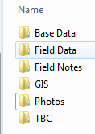

Download Data from Survey Controller
Connect your Trimble controller to the computer via USB as shown below.
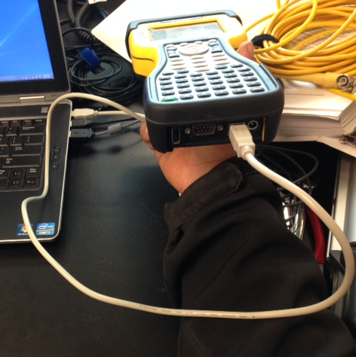
If the computer recognizes the device a Windows Mobile window should open. Close the Windows Mobile Window. Open the program Data Transfer and ensure the software is connecting to your controller.
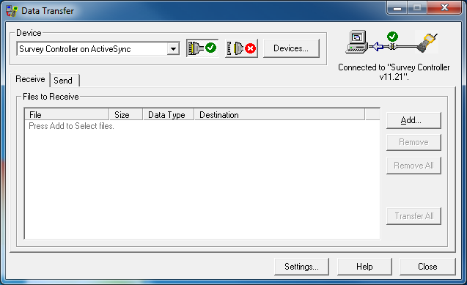
Click Add. Select the job file you wish to import. Click browse and point it to the “Field” folder for the job (for example: 20140815_CoastalErosionSegmentB/Field). Click Open. You can repeat these steps for any other jobs you wish to transfer at this time. When all jobs are added click Transfer All. Once the folder is transferred a message box will pop up reading “Transfer Completed”. Click close.

TBC Initial Configuration

Create a “Project Template” for Barrow (if exists, skip this step)
Create a template in TBC on each processing computer. NOTE: If a template already exists proceed to section “4.5 Creating a New TBC Project.”
- Start TBC and under common tasks start a new project and select the Metric Template.
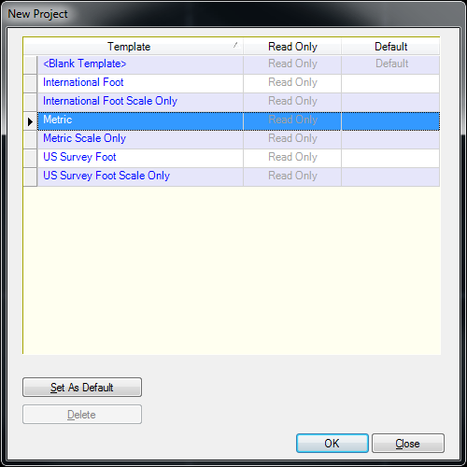
- Change the Coordinate System Setting in the project setting dialog. Go to Project/Project Settings/Coordinate System
  - From the Coordinate System Summary select “Change” 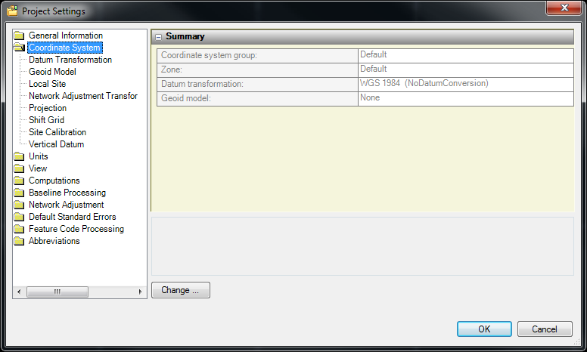
  - Select Coordinate System and Zone and click Next. 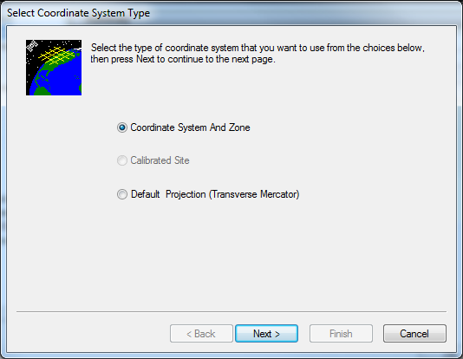
  - For Coordinate System Group select “UTM” and for Zone select “4 North”. 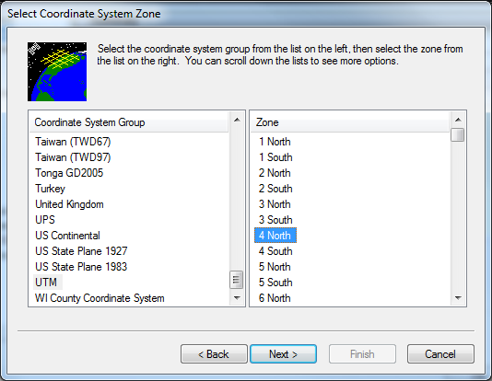
  - For Select Datum Transformation select “NAD 1983 (Alaska)”. 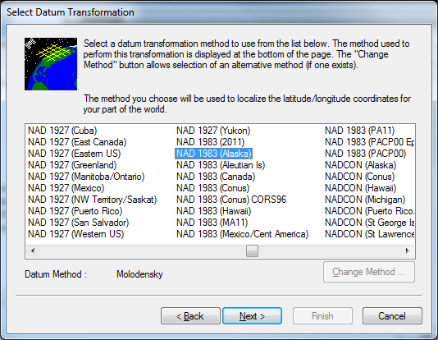
  - For Select Geoid Model choose “GEOID99 (Alaska). 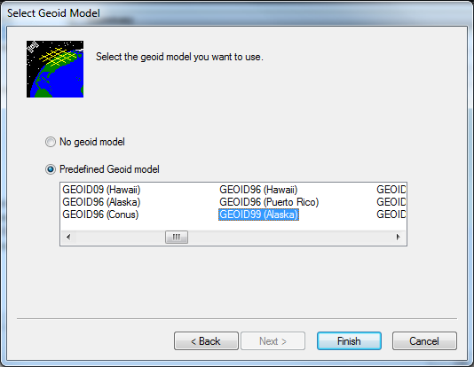
  - Your Project Settings Coordiante System settings should now look like this: 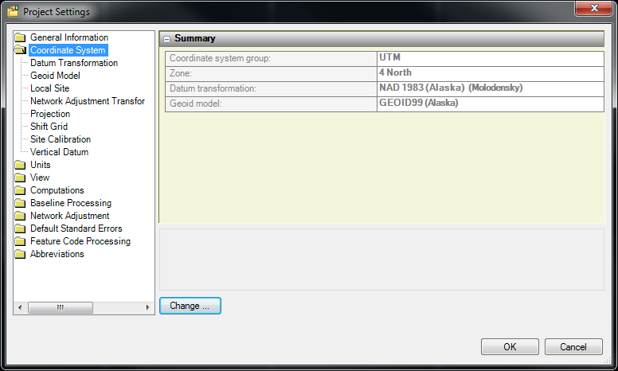
- Change the default continuous topo processing settings.
  - In the Project Settings dialog navigate to Baseline Processing>General. Change the “Store continuous as trajectory:” option to “No”. Click OK.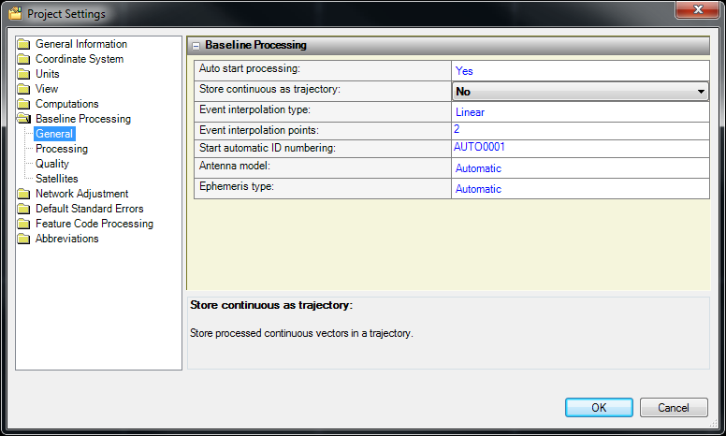
- Save the project as a template. Go to File>Save Project As Template. Name the template “BAID Barrow UTM”, check the box for “Save project as default template”, and click save.
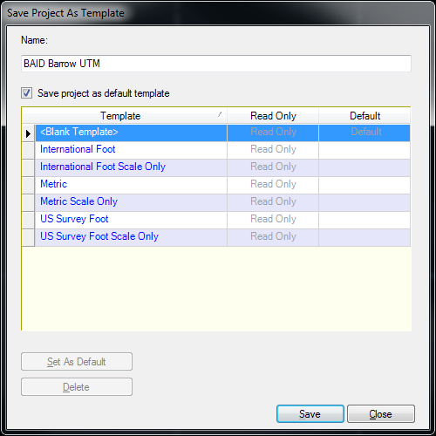

- You now have a preconfigured template for processing DGPS surveys in Barrow.

httpCreate a new TBC Project
- In TBC go to File>New Project…
- Select the BAID Barrow UTM template and click OK.
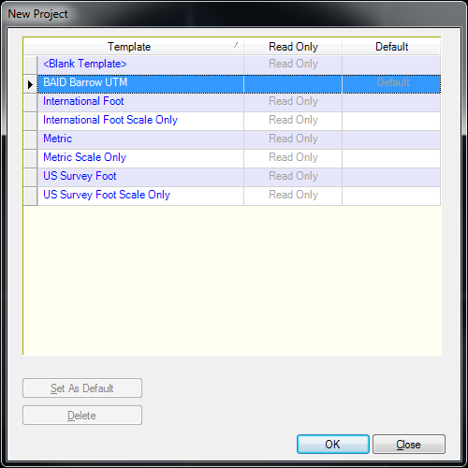

- Save the project in a “TBC” folder in the folder for the DGPS job you will be processing. For example “C:\ DGPS\NIMS-ITEX_20130603\TBC\NIMS-ITEX_20130603.vce”. Your specific folder structure will be unique to each job.
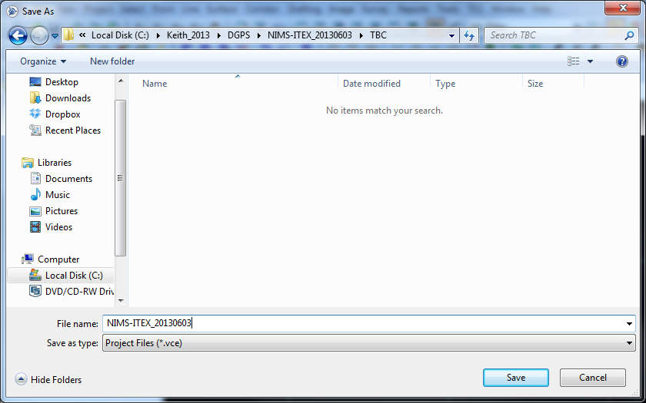

- You are now ready, add your field and base data.

Load Field Data from File
- Add your field data to TCB by clicking the import button.
- In the Import window, navigate to the folder where you have stored your survey data. 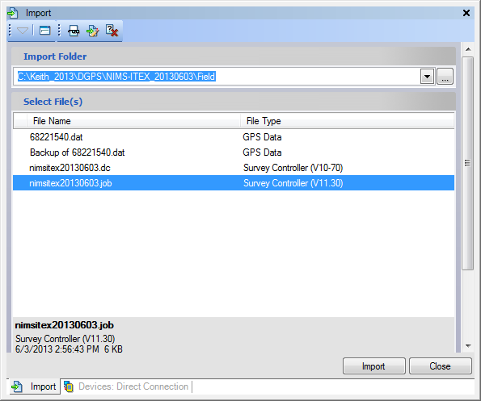
- Select the .job files and click Import.
- In the Receiver Raw Data Check In window insure that your points are selected and click ok. 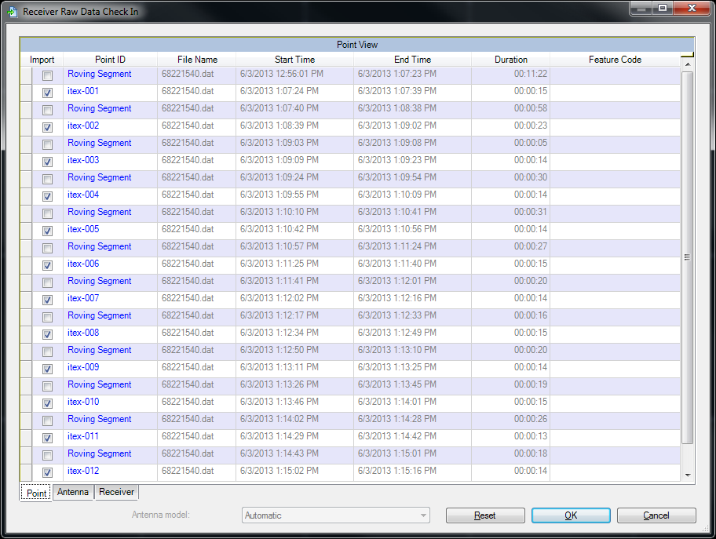
- Your surveyed points should now appear in the Plan View. 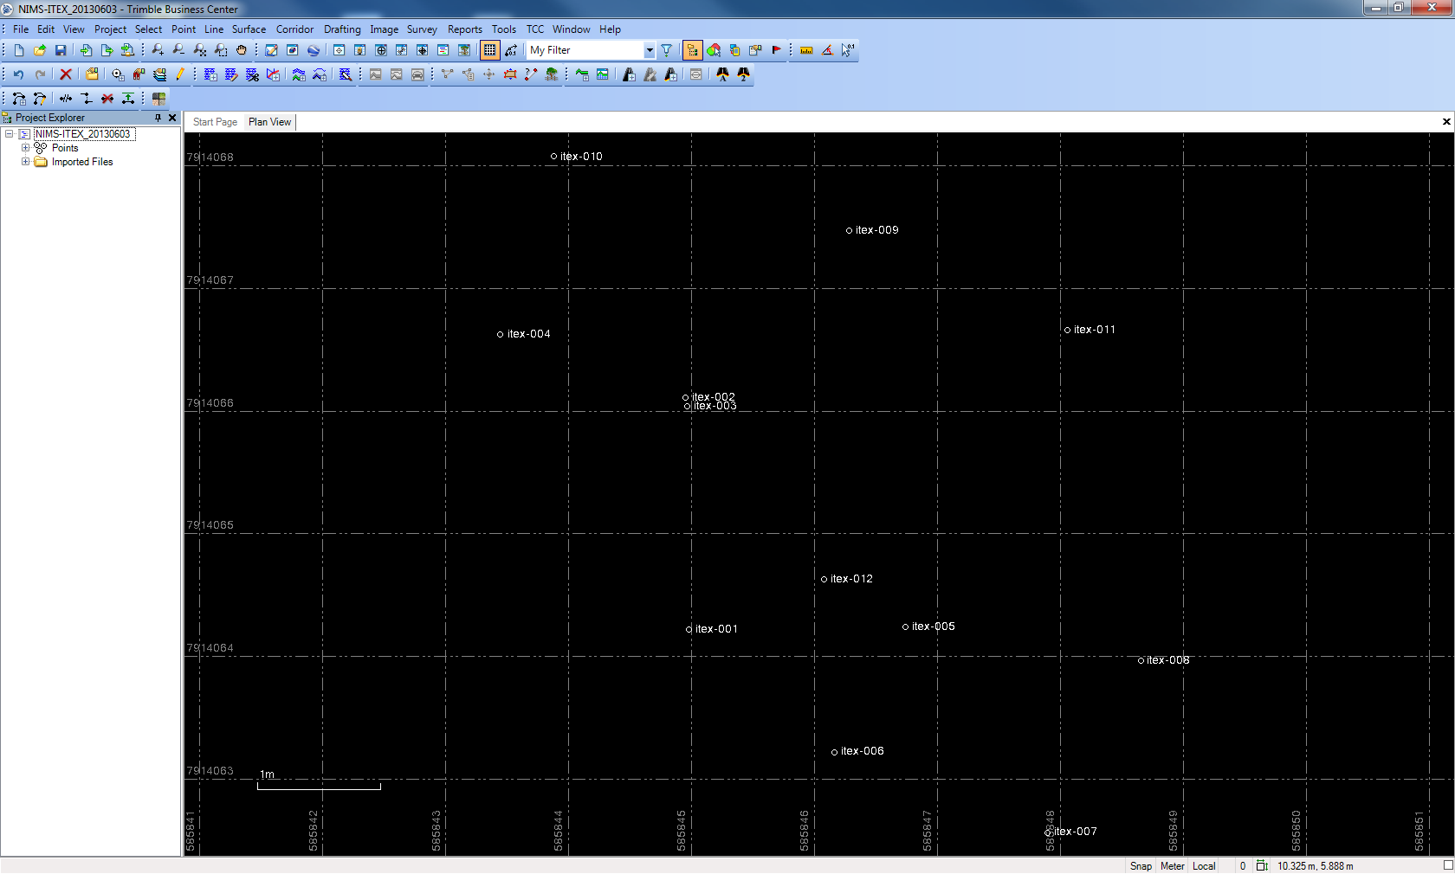

How to add an online base station (grab from section in Amorita’s doc)
Include Atqasuk IP

Import Base Station data from the Internet
- Click on the Import from Internet button .
- In the Internet Download window from Reference Stations select BASC and click Automatic. 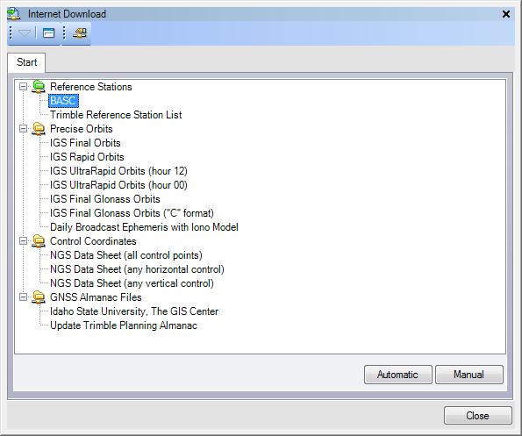
- In the Download Parameters window accept the defaults and click OK. 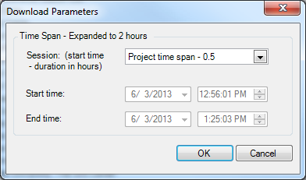
- TBC should automatically identify the base files that cover your survey, if this looks correct click Import. 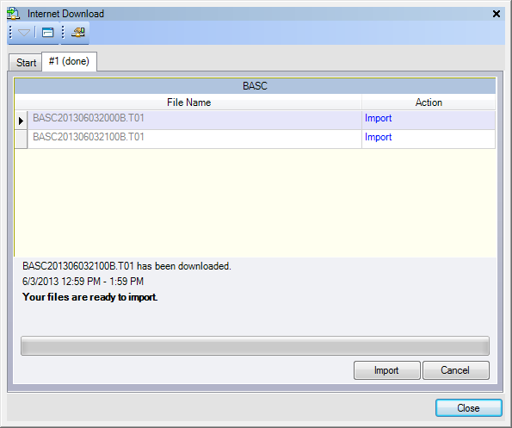
- Review the base station data in the Receiver Raw Data Check In window. If it looks good click OK. Close Internet Download window. 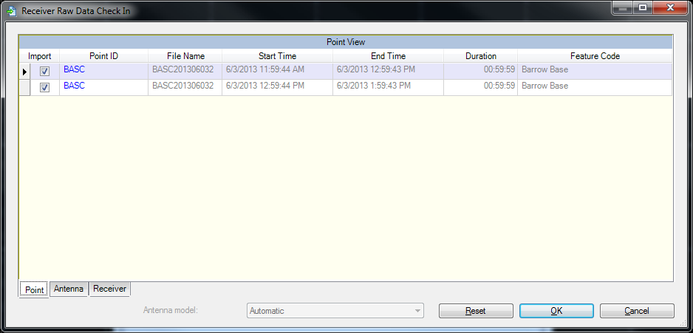
- In Plan View you should now see the base station and your survey data with base lines. 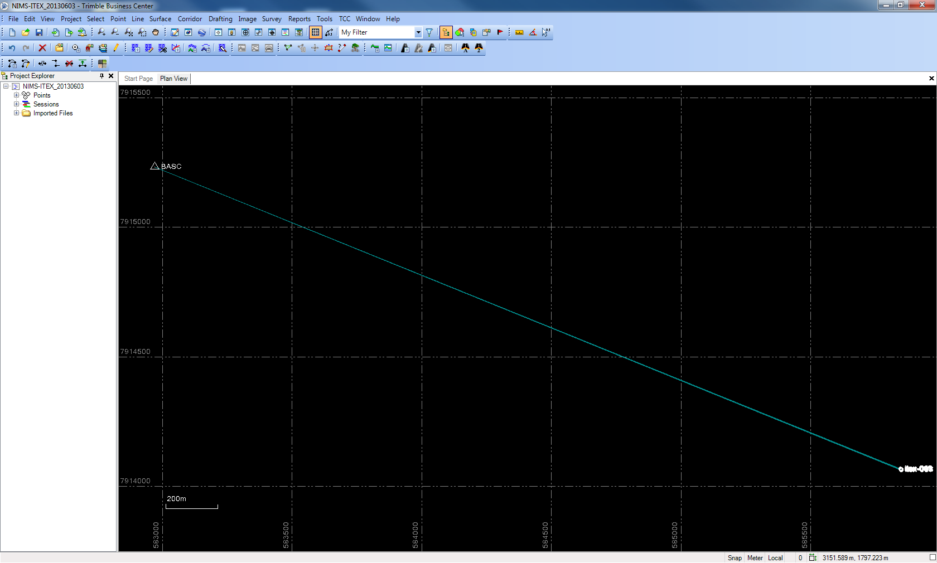

Note: If you post process a “Continuous Topo” survey, you will not see a base line until you’ve processed and saved?

How to add a base station if not configured on processing terminal
Skip this section if already configured.
Access the “Internet Download” frame and then the “Internet Download Configuration.”
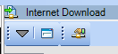
In the resulting “Internet Download Configuration” window, click the “New Site” button.
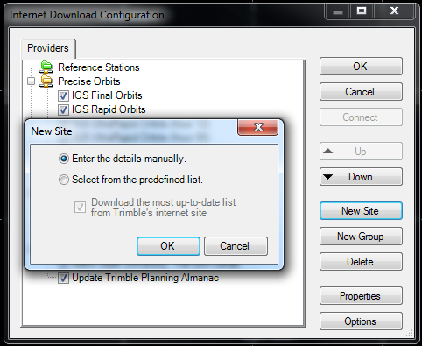

Enter the “Site Name” and “Host URL” as shown below:
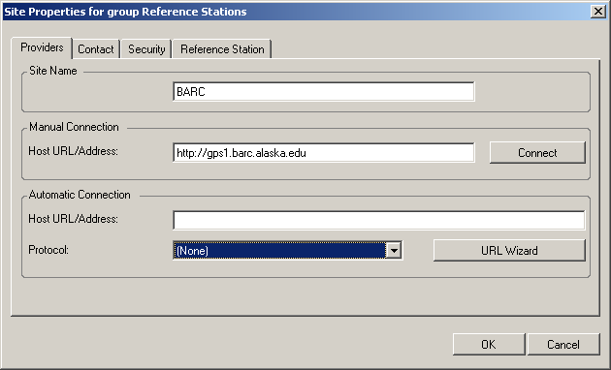

ftp://gps1.barc.alaska.edu/Internal/%YYYY%%MM%/%DD%/1hr1hz/BARO%YYYY%%MM%%DD%%HH%00B.T01

Next click “URL Wizard” and then the “Request Session Data” button.
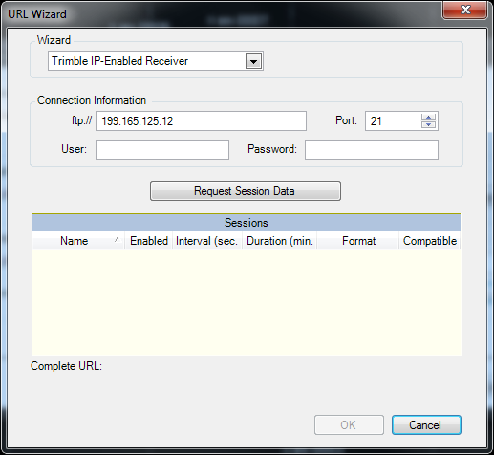
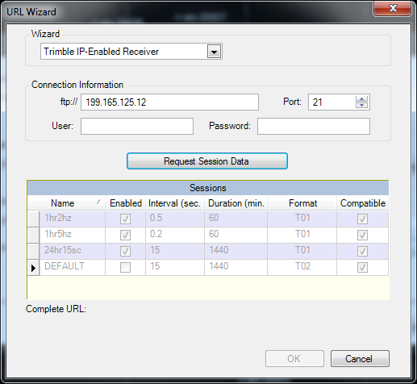
Highlight the” 1hr2hz” session and then “ok” and the resulting screen should appear as follows:
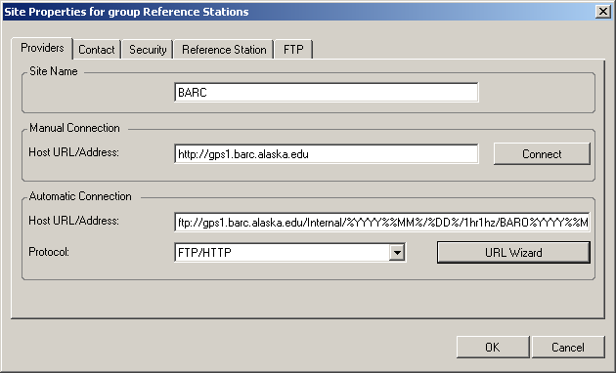
Click “Ok” and now the “BARC” base station should be listed under Reference Stations.
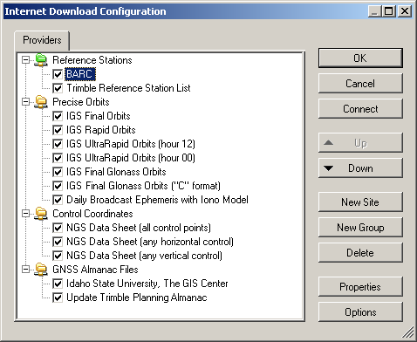
Select “Ok.”

Process Baseline
- You can now process base lines. Make sure that none of your Points or Secession are selected by clicking somewhere on the map without any features (alternatively you could select everything, but the selecting nothing method insures that you don’t miss anything). Begin processing baselines by clicking on the process base line button or by going to Survey/Process Baselines. The Process Baselines window will open. Wait for the processing to finish. This may take a while if you have many points. 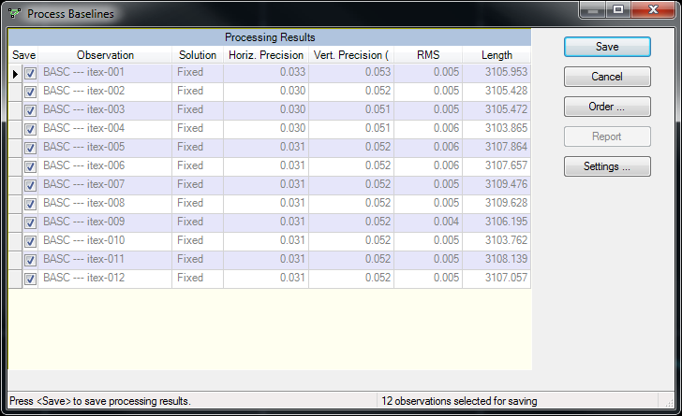
- Review you base line Processing Results and click Save if you are satisfied with the results (if you had failed base lines you may need to cancel and change some setting before attempting to process again).
- Your processed baselines should now appear blue. 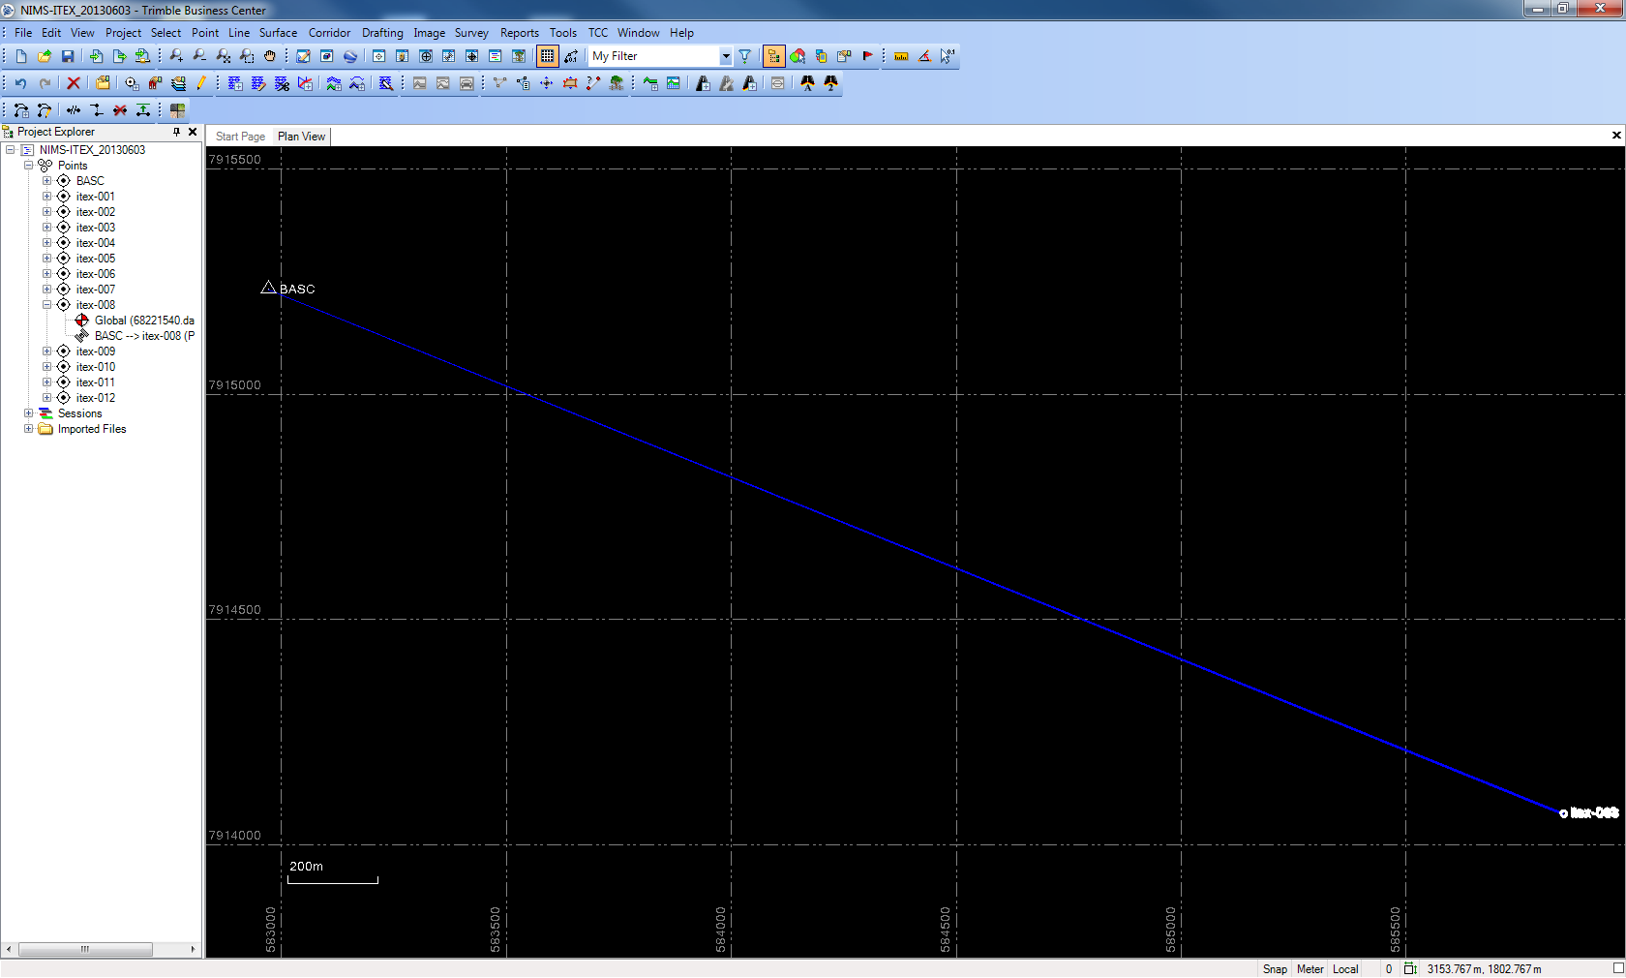

Process Continuous Topo

Exporting Processed Data
(Note: Need to add custom BAID export

Create a Custom Export Format

- Click the export button or go to File/Export. The Export dialog will open. Choose “Custom”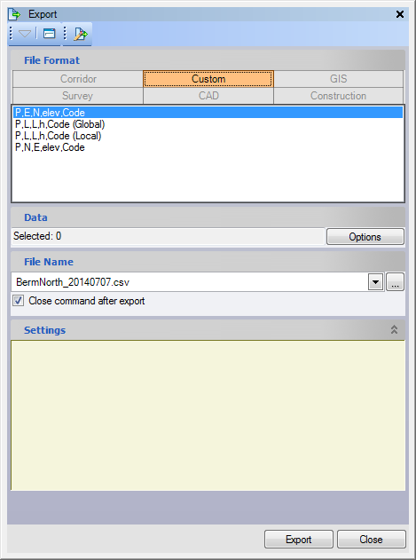

- Click on the “Export Format Editor” tab

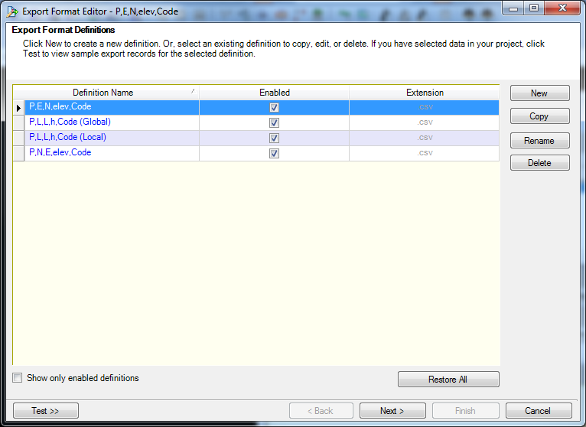
- Highlight “P.N.E.elev.Code” and choose copy
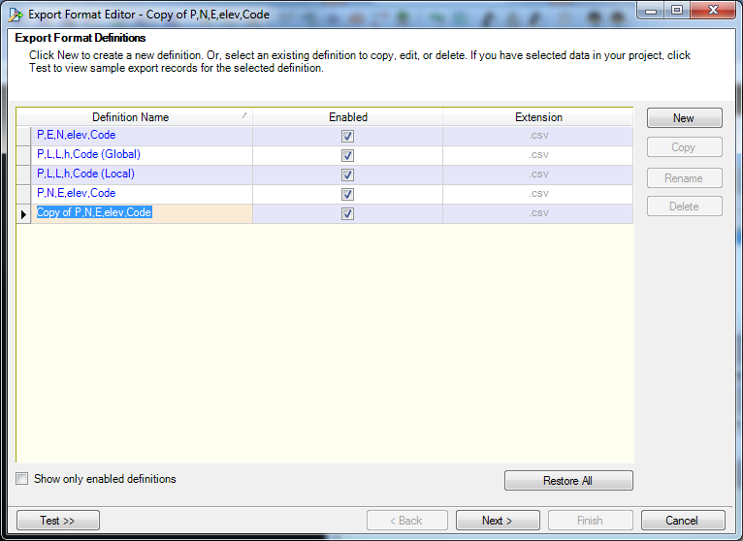
- Now rename new definition format “BAID Barrow”
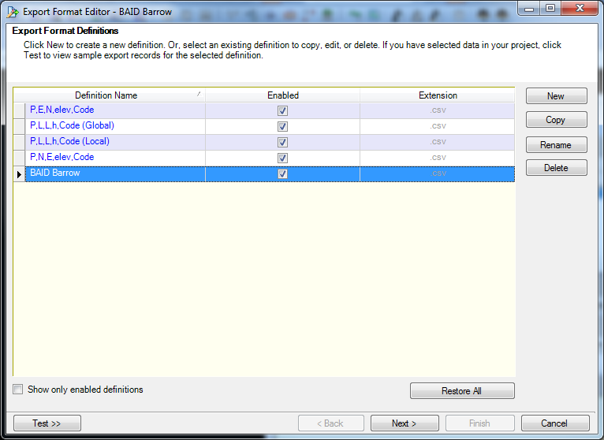
- Now, with the field highlighted, click the “Next” button.
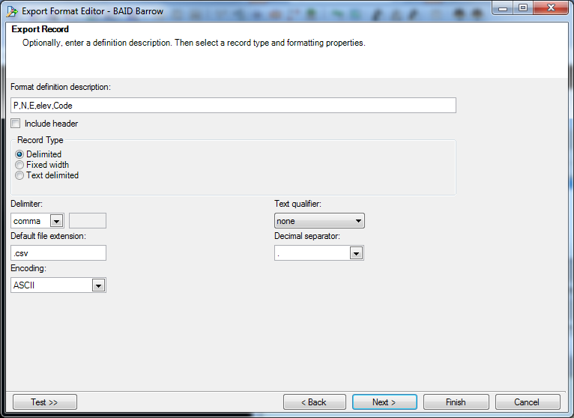
- Now choose your own “Format definition description” , check box for “Include Header” and leave everything as default then click next.
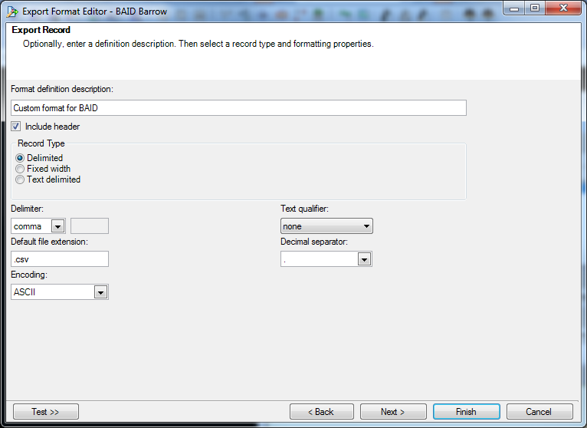

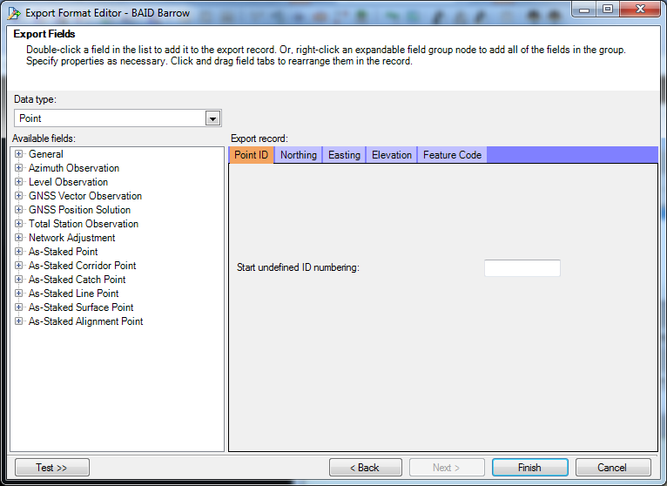
- You’ll now choose the fields to include and remove in the custom export. This is done in the “Available Fields” window. To select fields, double click them. To remove fields, right click and choose remove from field. Field names that are colored grey are selected.
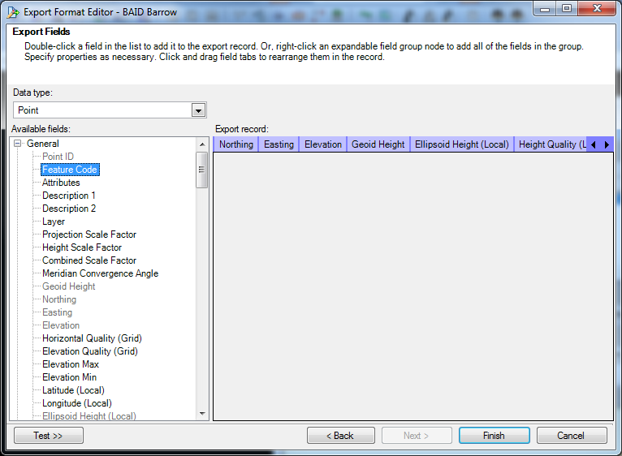
- Under the “General “ category, remove “feature code”. Next, add the following fields, “geode height”, “ellipsoid height”, “height quality”, “latitude (global)”, “longitude (global)”, “ellipsoid height (global)”, “horizontal quality (global)”, “height quality (global)”.
- Next, under the “GNSS vector observations” category, add the following fields, “solution type”, “H. precision”, “V.precision”, “PDOP”, “satellites”.
- Click finish.

Working With Problem Surveys, Changing the Baseline Processing Tolerance, Forcing Float Solutions to Process and Importing Roving Sections of a Survey to Fill in Gaps.

1. Within desired TBC project click on “Survey” menu tab and choose “Clear Processing Results”.
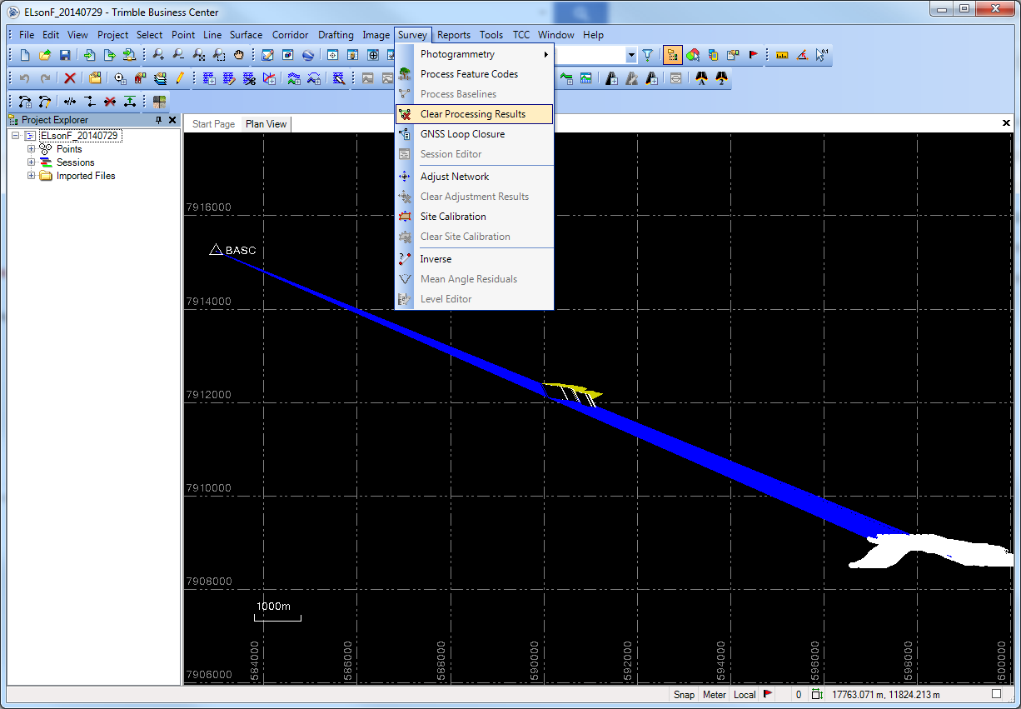
2. Next, right-click the project name in the “Project Explorer” window and choose “Project Settings”.
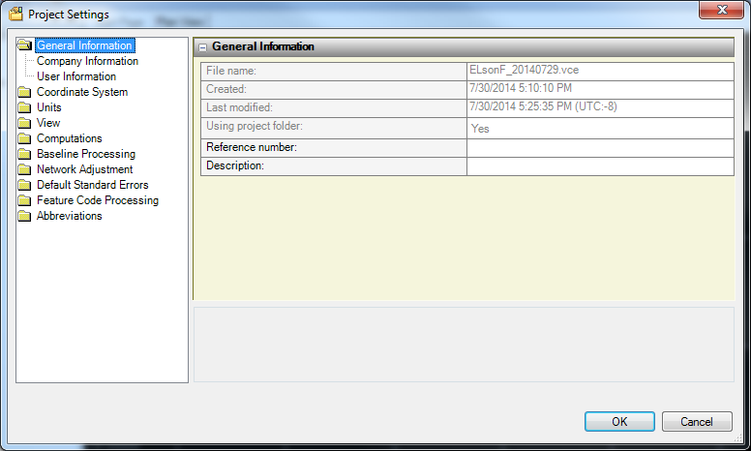
3. Click on the “Baseline Processing” tab and click on “Quality”. Here, you can change the “Fail” qualities to 5.00 m for horizontal precision and 10.00 m for vertical precision.
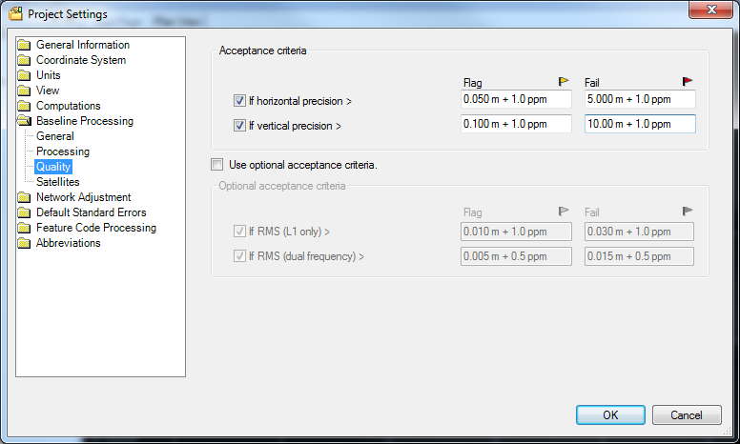
4. Next, click on the “Satellites” tab and change the “Elevation Mask” value to 5.00 deg and click OK.
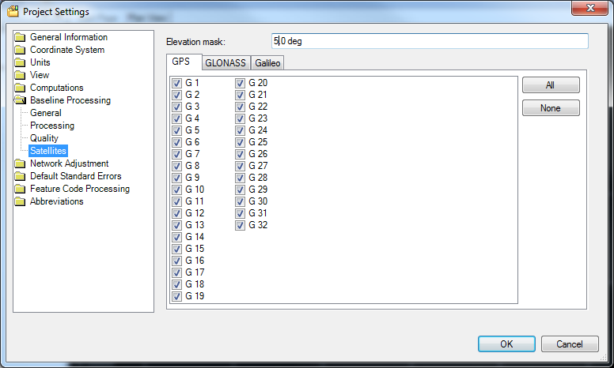
5. To reprocess the baselines, click the “Process Baselines” button. The “Process Baselines” window will pop-up and automatically begin processing.
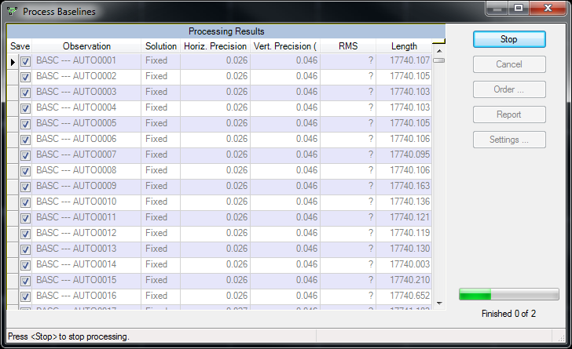
6. To force “Float Solutions” to process, highlight all rows with Float solutions, right-click “Save” and choose “Check selected rows”.
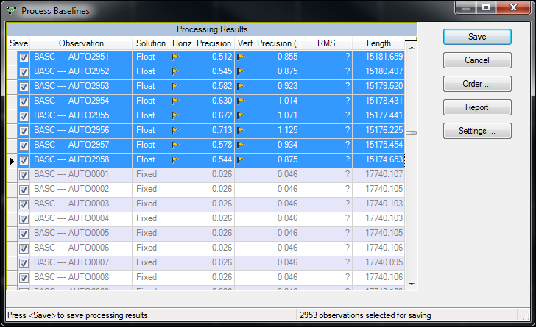

View Exported DGPS data in Quantum GIS

Format the CSV Data and Save as an Excel Spreadsheet
1. Open export in Excel and rename columns with shapefile friendly names. You can copy and paste field names below.
Point_ID | Easting | Northing | Elevation | Geoid_Ht | Ellip_Ht_L | Ht_Qlt_L | Lat_G | Lon_G | Ellip_Ht_G | Hori_Qlt_G | Ht_Qlt_G | Soln_Type | H_Precsn | V_Precsn | PDOP | Satellites

Appendix

Check list for heading to the field with R7

Check list for heading to the field with R8

Equipment Inventory at Barrow
last updated August 18, 2014

